SECTION 9 SEDIMENT SIMULATION

9.1 Introduction to the Sediment Simulation
Sediment is a concern in the Chesapeake Bay watershed due to its detrimental effects on water clarity as well its impact on riverine habitats, impaired drinking water quality, reduced reservoir storage, and impairments to flood control measures. An accurate simulation of sediment processes and behavior contributes to development of sound sediment load reduction strategies as well as providing a basis for sediment transport of phosphorus and other sediment-bound constituents.

The HSPF model code simulates sediment transport as separate processes on the land and in the river. Corresponding to the model structure, the Phase 5 sediment simulation is described here in three parts - first land calibration of the edge-of-field loads, then calculation of the transport of sediment from the edge-of-field to the edge-of-river, and finally river calibration to monitoring stations (Figure 9.1). Factors adjust the edge-of-field load for land area and any Best Management Practices (BMPs) applied to the land. Combined, the three components simulate sediment sources, delivery, and transport within the watershed (Figure 9.1).
4. A delivery factor based on the land use distance from the stream is applied (see below), resulting in the Edge-Of-Stream load.
BMP Factor
Land Acre Factor
Delivery Factor
Edge-of-Field
Edge-of-Stream
1. Sediment processes are simulated on the land surface resulting in an Edge-Of-Field sediment load. More land use types are simulated in Phase 5.
2. A time series of Best Management Practices (BMPs) is applied based on available data.
3. A time series of land use acreage factors is applied.
5. Processes of deposition and scour are simulated in the stream, resulting in concentrations that can be compared to observations.
In Stream Concentrations

Figure 9.1. Phase 5 sediment simulation components.

9.1.2 Overview of Edge-of-Field Erosion
The Phase 5 Watershed Model simulates erosion from the land surface and the transport of sediment in river reaches. It is important to distinguish the different phases of erosion and sediment transport and the calibration methods associated with them. Precipitation and surface runoff cause sediment to erode from the land surface. The sediment loss from a field is the edge-of-field (EoF) load. The target edge-of-field loads Phase 5 is calibrated to is estimated by the National Resource Conservation Service’s (NRCS) Universal Soil Loss Equation (USLE) or the more recent Revised Universal Soil Loss Equation (RUSLE) for many land uses using the National Resource Inventory (NRI) database (National Resources Inventory, 2007). For other land uses literature values provide a calibration target for the EoF loads.

9.1.2 Overview of Edge-of-Field to Edge-of-Stream Transport
Not all of the EoF sediment load is delivered to the stream or river. Some of it stored on fields down slope, at the foot of hillsides, or in smaller rivers or streams that are not represented in the model. The ratio of the sediment load at the EoS to the EoF load generated in the watershed is the sediment delivery ratio or sediment delivery factor (DF). The edge-of-stream (EoS) load is the load delivered to the represented river or stream from the land segments. The EoS sediment load can therefore be represented as the product of the EoF load and the sediment delivery ratio. The delivery factor for each landuse in a river segment is determined by the average distance that landuse is away from the main river simulated in the river reach.

9.1.3 Overview of Riverine Transport
Additional processes come into play in river reaches. Sediment can be deposited in a reach, or additional sediment can be scoured from the bed and banks and throughout the watershed segment. The load delivered at the reach outlet can be represented by the following components:

Load at Reach Outlet = EoF*DF + (Scour – Deposition)

where:
EoF = edge-of-field load (lbs/ac-yr)
DF = edge-of-field load to edge-of-stream load delivery factor
Scour = scour of sediment throughout the watershed segment due to high flow
Deposition = deposition sediment in the watershed segment due to low flow

The first term, the EoF load, is the end result of the land processes simulation using HSPF’s PERLND and IMPLND modules. The second term is a function of the distance the average landuse is from the river reach simulated, and the net scour or net deposition terms are simulated in the stream network with the RCHRES module.

Expanding the calibration procedure described in “Sediment Parameter and Calibration Guidance for HSPF” (USEPA, 2006), the simulation of erosion and sediment transport is calibrated as follows:

- Sediment loads for each land use in the form of estimated edge-of-field load targets are determined, based on National Resource Inventory estimates or by literature survey.
- All land uses in each land-segment are calibrated to the estimated edge-of-field load targets.
- Delivery factors are calculated for each land use by their average distance from the simulated reach to adjust the edge-of-field (EoF)sediment load to the edge-of-stream (EoS) sediment load.
- The influence of best management practices (BMPs) in reducing EoS loads is calculated.
- Reach processes are calibrated against monitoring data using user defined parameters of scour, deposition and erodibility.

Each of these steps are explained below in detail.

9.2 Sediment Loads by Land Use
The first step in the sediment calibration for each land use is to calibrate the simulated loads to the expected annual average edge-of-field erosion rates. The expected annual average EoF sediment load rates are provided for crop, pasture, hay, and forest by the National Resources Inventory (NRI) (Nusser and Goebel, 1997; National Resources Inventory, 2007) which are edge-of-field annual average erosion rates estimated from Universal Soil Loss Equation (USLE) or the Revised Universal Soil Loss Equation (RUSLE), as described below. Urban loads are estimated from a regression based on sediment export studies. Other land uses use literature values of expected EoF sediment load rates.

Development of Edge-of-Field Erosion Rate Estimates
The EoF expected annual erosion rate estimates, also called “target loads”, are based on observed data, literature values, or other assessments such as the National Research Institute (NRI) data. Calibration of sediment starts with matching the simulated EoF sediment loads with the target loads. The target loads are represented in units of tons/acre-year (ton/ac-yr).

9.2.1 Crop Land – Conventional Tillage, Conventional Tillage With Manure Application, and Conservation Tillage With Manure Applications

The Phase 5 simulation has two cropland tillage types, conventional and conservation tillage, which are used to represent a wide range of tillage practices. Cropland erosion, or EoF sediment loading rates, are estimated by using the average NRI county estimates for the years of 1982 and 1987 (Nusser and Goebel, 1997; National Resources Inventory, 2007.

Crop EoF sediment loading rates vary over the available NRI sampling periods of 1982, 1987, 1992, and 1997, and trend toward lower estimated erosion rates in more recent sampling periods. This may be due to an increased rate of BMP application, newer, more efficient BMP approaches such as integrated farm plans, other agricultural factors such as changing management practices or crop type, or may simply be sampling differences. This downward trend is also seen nationally in other river basins and is attributed to improved conservation measures (Figure 9.2.1). For the Phase 5 edge-of-field erosion target for crops, the average of the NRI estimated erosion rates for cropland for the NRI assessment years of 1982 and 1987 are used.
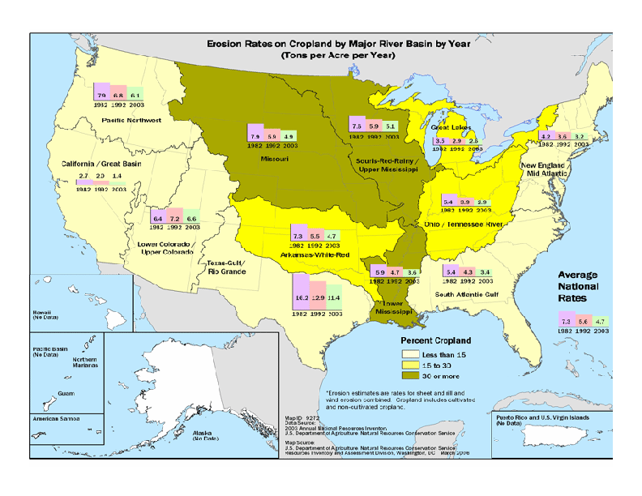
Figure 9.2.1. National trends in erosion rates.

The downward trend in the NRI data of estimated erosion rates from 1982, 1987, 1992, and 1997 is assumed to be due to general improvements in management practices, a trend which would cause double-counting if this reduction is represented first by the full 1982-1997 average of the NRI data and then by the application of load reductions by sediment BMPs. To avoid potential double-counting of BMP reductions in sediment loads, and for operational simplicity, a two-year (1982-1987) NRI estimate was used for each crop land use. Overall, the two year average was thought to best represent the Phase 5 simulation approach of using a base rate of sediment edge-of-field loading rates and subsequently modifying the loading rates though application of BMPs as reported in state BMP implementation data bases.

Differences between tillage practices are unavailable from the NRI data base. Consequently, the overall crop EoF sediment load estimates from NRI are adjusted for conventional tillage practices, conservation tillage practices, and hay land. Conservation tillage is broadly defined as cropland management practices which provide for 30% land surface cover at the time of planting. Tillage practices which provide at least 30% cover at the time of planting vary widely (Angle et al., 1984; Angle, 1985; Camacho, 1990; Langdale et al., 1985; SCS, 1988; Staver et al., 1988). Some conservation tillage practices that result in minimum soil disturbance, and leave high crop residue cover, such as no-till practices, have high sediment reduction efficiencies on the order or 80-90%. Other conservation tillage practices disturb soils to a greater extent and leave less crop residue cover, resulting in lower efficiencies of around 40%. We conservatively assume sediment erosion reduction efficiencies of conventional tillage compared with minimum tillage of whatever means that leaves 30% crop residue cover at the time of planting, provides a sediment reduction efficiency of 40% compared to conventional tillage practices (Table 9.2.1.4). Other sediment BMPs, applied with conservation tillage would reduce sediment loads further.

The NRI crop edge-of-field sediment load estimates represent an aggregate of all tillage practices. As we are using the average of the 1982 and 1987 NRI data, and conservation tillage practices are about half of total cropland tillage practices during this period, and we’re assuming a difference between conventional and conservation sediment edge-of-field load rates of about 40%, the edge-of-field sediment loading rates for conventional cropland are set at 125% of the NRI crop estimates and rates for conservation cropland are set at 75% of the NRI estimates.

9.2.1.1 Plow Actions, Field Operations, and DETS
Plow dates for each crop were set at the 15th of the month prior to the first month of the year in which canopy cover is greater than zero. The total amount of detached sediment (DETS) added per year for each crop was taken from the previous Phase 4.3 model application. All conventional tilled crops received a total of 5.5 ton/ac-yr of DETS and conservation tilled crops received a total of 2 ton/ac-yr DETS. Since composite crops are made up of many crops that are plowed at different times of the year, the total DETS in each composite crop were distributed proportionally to the percent composition of each constituent crop and assigned the plow date of that crop. Table 9.2.1.1 shows the annual time series of DETS for the different crops comprising the three composite crops in several typical land segments.

Need to make Table 9.2.1.1

9.2.1.2 Cover
Cover is an important parameter in the Phase 5 sediment simulation. Cover represents both the living vegetative canopy and all ground covers such as leaf litter. The presence of cover, expressed as a percent of ground covered, prevents the initial soil erosion from rain drop detachment of soil particles from the soil matrix. The rain detached soil particles would then contribute to the pool of detached soil material available for wash off (DETS). Since DETS is decremented by a small portion at each time step as soil particles are reattached to the simulated soil matrix, a land use with 100% cover would erode little, if at all. In HSPF the cover is set monthly but interpolated between user-defined monthly rates for each simulation day.

Monthly cover in Phase 5 is assumed to be the sum of monthly canopy cover from the Revised Universal Soil Loss Equation 2 (RUSLE2)², and the monthly residue cover. Table 9.2.1.2 lists the agricultural land use crop types, and what crop is used from RUSLE2 to determine the monthly canopy cover. If a crop is not listed, it is because there is no equivalent crop in RUSLE2, or because that crop is not applicable in this circumstance. Since the land use crop types often had many different breakouts in RUSLE2, the breakout that was closest to the Bay was chosen.

Table 9.2.1.2 Relationships among the AgCensus crop types and the RUSLE crop types.
Agricultural Land Use Crop Type | RUSLE2's equivalent
Corn for Grain | corn, grain
Corn for Silage | corn, silage
Soybeans | soybean, southern 15-20 in rows
Small Grain | winter wheat S.E.
Cotton | cotton southern upland or cotton delta
Tobacco | flue-cured
Potatoes | Irish potatoes

Many different vegetables are included in the vegetables crop type; therefore the largest vegetable by acre was used to decide what vegetable to pull from the RUSLE2 database for monthly canopy cover. Monthly canopy cover for sweet potatoes, sorghum, and dry edible beans were not available. For these crops, sweet potatoes were included with potatoes, sorghum with corn, and dry edible beans with soybeans. Monthly cover was unavailable for counties in Tennessee or North Carolina. For these counties, the percent cover from the Virginia region closest to each county was used.

Since RUSLE2 only provides the canopy cover, the crop residue cover was calculated and added to the RUSLE2 canopy cover numbers, to come up with the true monthly cover. In order to simulate variation found in actual agricultural settings, the estimated residue amounts varied by crop, tillage and climatic region. Baseline residue levels at planting and harvest were estimated for each crop and climatic region (Personal Communication 3/6/07, Mark Dubin, University of Maryland, March 2007). Residue decay rates were then used to interpolate changes in residue amounts between harvest and planting. Table 9.2.1.3 shows the range of values for corn, soybeans, and wheat for the two major climatic regions. A complete list of crop residue and canopy factors can be found at <HOTLINK CANOPY AND CROP RESIDUE TABLE HERE> In general, decay rates are assumed to be governed by temperature, therefore they are somewhat lower in colder regions. During the winter months of December, January, and February, the decay rate remained at a steady value. This decay rate was then added to the RUSLE2 monthly canopy cover to determine the total monthly percent cover.

Need to make Table 9.2.1.3.

Phase 5 land uses include composite crops. For these crops, the percent cover for each month is calculated as an area-weighted average of the percent cover for each of the individual constituent crops. Similarly, the residue is an area weighted residue cover for each crop. The following formula was used to create this acreage-weighting (where n = the number of crops on a given land use, r = residue fraction of crop “i”, c = canopy fraction of crop “i”, and a = the area of crop “i”):

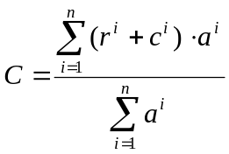

For the years 1990 and 2000, percent cover was calculated as a linear interpolation of 1982, 1987, 1992, and 1997. Tables 9.2.1.4., 9.2.1.5, and 9.2.1.6 show the average percent cover in each state for each crop type. Full percent cover data can be found using <HOTLINK COVER TABLE HERE>.

Through consultation with the Nutrient Subcommittee, the monthly cover for pasture, alfalfa, the hays, and berries were determined. Since berries usually have either an artificial or hay ground cover, the monthly cover was assumed to be 95% for each month. Berries are part of the Conventional Tillage Without Manure composite crop, and the cover for this land use is adjusted by area weighting of the different crop types.

Table 9.2.1.4 Average percent cover Conventional Tillage Without Manure.
STATE | Jan | Feb | Mar | Apr | May | June | July | Aug | Sep | Oct | Nov | Dec
DE | 0.07 | 0.07 | 0.06 | 0.08 | 0.23 | 0.36 | 0.48 | 0.50 | 0.57 | 0.64 | 0.08 | 0.07
MD | 0.09 | 0.09 | 0.09 | 0.19 | 0.28 | 0.46 | 0.64 | 0.68 | 0.69 | 0.67 | 0.44 | 0.09
NC | 0.07 | 0.07 | 0.07 | 0.07 | 0.13 | 0.53 | 0.86 | 0.65 | 0.28 | 0.13 | 0.08 | 0.07
NY | 0.12 | 0.12 | 0.11 | 0.12 | 0.24 | 0.35 | 0.47 | 0.58 | 0.65 | 0.73 | 0.13 | 0.12
PA | 0.12 | 0.12 | 0.11 | 0.16 | 0.27 | 0.42 | 0.61 | 0.71 | 0.34 | 0.15 | 0.13 | 0.12
TN | 0.07 | 0.07 | 0.06 | 0.06 | 0.12 | 0.54 | 0.88 | 0.63 | 0.26 | 0.11 | 0.08 | 0.07
VA | 0.11 | 0.11 | 0.11 | 0.17 | 0.26 | 0.49 | 0.71 | 0.66 | 0.56 | 0.45 | 0.23 | 0.11
WV | 0.12 | 0.12 | 0.12 | 0.20 | 0.34 | 0.52 | 0.70 | 0.57 | 0.61 | 0.60 | 0.13 | 0.12

Table 9.2.1.5 Average percent cover Conventional Tillage Receiving Manure.
STATE | Jan | Feb | Mar | Apr | May | June | July | Aug | Sep | Oct | Nov | Dec
DE | 0.29 | 0.31 | 0.29 | 0.32 | 0.41 | 0.59 | 0.62 | 0.59 | 0.50 | 0.28 | 0.25 | 0.26
MD | 0.29 | 0.30 | 0.29 | 0.31 | 0.35 | 0.56 | 0.63 | 0.59 | 0.50 | 0.25 | 0.24 | 0.25
NC | 0.41 | 0.46 | 0.45 | 0.47 | 0.44 | 0.64 | 0.70 | 0.65 | 0.56 | 0.34 | 0.33 | 0.37
NY | 0.25 | 0.25 | 0.24 | 0.28 | 0.51 | 0.87 | 0.87 | 0.67 | 0.19 | 0.20 | 0.20 | 0.21
PA | 0.30 | 0.32 | 0.32 | 0.32 | 0.27 | 0.58 | 0.81 | 0.74 | 0.60 | 0.24 | 0.24 | 0.26
TN | 0.12 | 0.12 | 0.11 | 0.10 | 0.14 | 0.60 | 1.03 | 0.93 | 0.74 | 0.16 | 0.13 | 0.12
VA | 0.32 | 0.35 | 0.34 | 0.36 | 0.37 | 0.60 | 0.72 | 0.66 | 0.55 | 0.27 | 0.26 | 0.28
WV | 0.26 | 0.26 | 0.25 | 0.25 | 0.18 | 0.51 | 0.84 | 0.75 | 0.61 | 0.21 | 0.22 | 0.23

Table 9.2.1.6 Average percent cover Conservation Tillage Receiving Manure.
STATE | Jan | Feb | Mar | Apr | May | June | July | Aug | Sep | Oct | Nov | Dec
DE | 0.42 | 0.44 | 0.41 | 0.45 | 0.64 | 0.83 | 0.90 | 0.90 | 0.78 | 0.50 | 0.42 | 0.41
MD | 0.42 | 0.43 | 0.40 | 0.42 | 0.58 | 0.85 | 0.92 | 0.91 | 0.82 | 0.50 | 0.43 | 0.41
NC | 0.40 | 0.42 | 0.39 | 0.41 | 0.57 | 0.82 | 0.90 | 0.89 | 0.80 | 0.48 | 0.41 | 0.39
NY | 0.38 | 0.38 | 0.35 | 0.37 | 0.69 | 0.91 | 0.92 | 0.93 | 0.77 | 0.42 | 0.39 | 0.37
PA | 0.43 | 0.44 | 0.41 | 0.40 | 0.43 | 0.76 | 0.84 | 0.84 | 0.81 | 0.45 | 0.42 | 0.41
TN | 0.40 | 0.40 | 0.36 | 0.33 | 0.38 | 0.84 | 0.96 | 0.96 | 0.96 | 0.46 | 0.43 | 0.39
VA | 0.38 | 0.39 | 0.36 | 0.38 | 0.56 | 0.84 | 0.91 | 0.91 | 0.82 | 0.47 | 0.40 | 0.37
WV | 0.42 | 0.42 | 0.39 | 0.36 | 0.36 | 0.74 | 0.83 | 0.83 | 0.83 | 0.45 | 0.42 | 0.40

9.2.2 Hay Land - Alfalfa, Hay-Fertilized, and Hay-Unfertilized
Hay lands are generally in constant cover and vegetation and are not plowed from year to year. Hay lands do have some soil exposure and disturbance from what is often several mowing and harvesting operations during the year, as well as periodic planting. Hay land is undifferentiated from other crops in the NRI data base. Earlier versions of the Watershed Model set hay erosion rates at about 32% that of crop land erosion estimates. Consequently, hay land edge-of-field erosion rates are set at 32% of the cropland rate for every county (Table 9.2.2).

Through consultation with the Nutrient Subcommittee, the monthly cover for pasture, alfalfa, the hays, and the berries was determined. Alfalfa and the hays have 95% cover year round.

9.2.3 Pasture
For the pasture land use, the estimated NRI erosion rates by county are applied (Table 9. 2.2) as erosion rates are considered to be a function of stocking rates, pasture management, soils, geography, and other factors unique for each county. The edge-of-field erosion target for pasture in each county segment is based on the average of the NRI estimated erosion rates for pasture for the NRI assessment years of 1982 and 1987 (Table 9.2.2).

Through consultation with the Nutrient Subcommittee, the monthly cover for pasture, alfalfa, the hays, and the berries were determined. Pasture is a little less than the alfalfa and the hays, with 90% for every month. This is due to the assumption that pasture has some cow paths and other bare spots due to animals. Since berries usually have either an artificial or hay ground cover, the monthly cover was assumed to be 95% for each month.

9.2.4 Degraded Stream Corridor
The degraded stream corridor land use represents unfenced riparian pasture with an associated stream degraded by livestock. This land use has high nutrient and sediment loads and is treated by riparian buffer BMPs. The sediment load target is set at 9.5 the pasture target rate for each county segment. Analysis of time spent by beef and dairy livestock in riparian areas is 9.5 times that spent in nonriparian pasture areas as shown by a study using continuous video tapes of riparian and nonriparian pasture areas. [Rob B. will provide the reference for this. On 3-14-08 Jeff S. was asked to update the information on this land use.]

9.2.5 Nutrient Management Pasture
Nutrient management pasture is pasture that’s part of a farm plan where crop nutrient management is practiced. Nutrient management pasture is pasture that receives manures that are excess on a farm after all crop nutrient needs are satisfied. Nutrient management pasture has the same sediment target rates as pasture.

9.2.6 Developed – Pervious and Impervious

The watershed model is constrained in the number of land uses it can represent. Two land uses, pervious developed and impervious developed, are used to simulate all the developed land uses of residential, commercial, institutional, industrial, and others. We use the pervious and impervious land uses to represent the two classes of Phase 5 developed land, the high-intensity developed and the low-intensity developed land uses as described in Section 10.2.1.16.

The simulation is spatially refined by the use of imperviousness estimated on every land-river segment (Figure 4.4). A percent imperviousness is determined for both the high-intensity and low-intensity developed land use at the land-river segment scale. The percent imperviousness provides an estimate of the mix of pervious and impervious area to be simulated on each Phase 5 land-river segment for both the high-intensity and low-intensity developed land uses.

For example, if a river-segment was estimated to have 100 acres of low-intensity developed land and the percent imperviousness was 10%, the 10 acres of impervious low- intensity developed land and 90 acres of pervious low-intensity developed land would be simulated. The same would be done for high-intensity developed land though typically with estimates of higher imperviousness.

Using the pervious and impervious developed land uses, which are assumed to be at levels of zero percent and 100 percent impervious respectively, the full range of sediment responses to the level of developed imperviousness is simulated and is reported as Phase 5 outputs of low-intensity developed and high- intensity developed land uses.

Erosion rates for developed lands are highly variable and, of all land uses, most likely to be augmented by sediment loads scoured from developed land waterways due to increased concentrated flow. Recent estimates of developed land erosion rates provide insight into the extent of imperviousness and the yield of sediment from developed areas (Langland and Cronin, 2003; Shaver et al., 2007; Trimble, 1997). At a watershed scale of measurement, Dreher and Price (1995) estimated post-development developed sediment loads for different land use categories. Also at a watershed scale, Langland and Cronin (2003) provided SWMM Model estimated sediment loads for different developed categories. Langland and Cronin (2003) point out that “for the watershed as a whole, approximately two-thirds of the sediment load was the result of channel erosion” due to the concentrated flow from impervious areas.

Combining this information, and assigning a percent imperviousness to each of the developed land uses in the three studies (industrial = 90%, commercial = 80%, low density residential = 15, medium density residential = 25%, high density residential = 35%, highway/arterial road = 50%, open land/developed park = 2%) we form a relationship between the degree of imperviousness and an associated sediment load (Figure 9.2.6.1). Using this relationship we calibrate developed pervious and impervious land to the values calculated at a level of 0% and 100% impervious respectively. Then, the estimated imperviousness of each land-river-segment is matched in area with appropriate combinations of pervious and impervious areas to calculate a unique sediment load for the level of imperviousness in each land-river-segment. The land use data base has estimated imperviousness for each 30 m by 30 m pixel for the years 1990 and 2000. Interpolation and extrapolation of these two years provides a unique developed area with associated imperviousness for each year in the simulation.

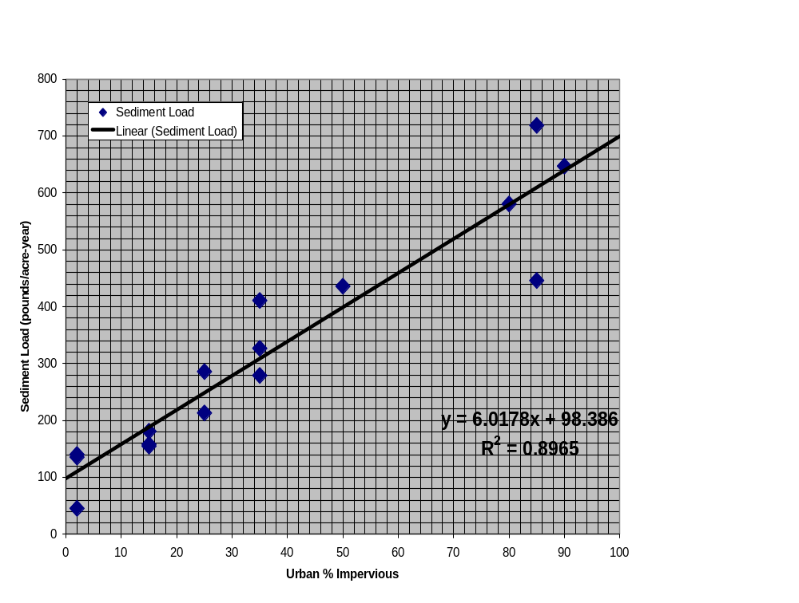

Figure 9.2.6.1. Relationship of sediment loads to degree of developed imperviousness. (Source: Langland and Cronin, 2003).

There remains the question of scale. Phase 5 operates on the assumption that all sediment loads are edge-of-field, and that transport and associated losses in overland flow and in low-order streams decrement the sediment load to an edge-of-stream input. To be consistent among all the land uses, the watershed scale of the Langland and Cronin (2003) estimates of sediment loads by different developed land uses needs to be placed in the same order of edge-of-field scale as the other Phase 5 land uses. To do this the estimated forest sediment loads provided in both studies are used. The average forest load estimates of these studies is 46 pounds/ac-yr, which represent the watershed scale delivered sediment load to an in-stream gaging station. This is compared to the NRI average Phase 5 forest load of 680 pound/ac-yr at the edge-of-field. To scale the watershed estimates to edge-of-field estimates, a factor of 14.8 was used.

9.2.7 Bare - Construction
Bare-construction is considered to be a transitional land use as forest or agricultural land uses are converted to developed land. Land area estimates of the bare-construction land use are based on the assumption that the bare-construction area is equivalent to 2.5 times the annual change in imperviousness (as described in Section 4).

Guy and Furguson (1962) reported annual sediment yields of 39 to 78 tons/acre-year from construction sites. The EPA estimates erosion rates to be between 7.2 to 500 tons/acre-year based on a number of sites (U.S. EPA, 2002). Included in the EPA assessment are Metropolitan Washington Council of Governments estimates of erosion rates of 35 to 45 tons/acre (MWCOG, 1987). We’re inclined toward the middle values of the two studies reported in the Chesapeake watershed (Guy and Furguson, 1962; MWCOG, 1987) to represent the erosion rate for bare-construction areas, and use a rate of 40 tons/acre-year specifically for the several month period of mass grading, a period of construction where most of the construction site is bare disturbed soil.

We assume that five phases of construction are sequenced on this land use over the project duration. The sequence of construction phases include 1) clearing and grubbing for erosion and sediment (E&S) controls, 2) clearing and grubbing the remainder of the site, 3) mass grading with completion of construction of buildings, roads, and other impervious structures, 4) partial site stabilization and building, and 5) final grade and stabilization.

Based on information from Trickett (2006) it is assumed that the clearing and grubbing for E&S controls will be approximately 5% of the total project duration with 10% of the site exposed. Clearing and grubbing the remainder of the site will last approximately 5% of the project duration with 75% of the site exposed at any given time. The mass grading phase is assumed to be 25% of the project duration with 75% of the site exposed at any time. With most of the site is disturbed, there will be a higher sediment yield during these last two phases (2 and 3). From partial stabilization to project completion, there will be a decreasing amount of exposed area due to completion of construction in various areas. It is assumed that partial stabilization will occur over 50% of the project duration with an average exposed area of 66% (2/3 total site). The remaining 15% of the project duration will have an average exposed area of 34% (1/3 total site).

During each of the construction phases, only a portion of the site is exposed and thus has the maximum erosion potential of 40 tons/ac-yr. To estimate an annual average construction site sediment yield, it is assumed the project duration is one year and then the 40 tons/ac/yr is adjusted based on the portion of the site that is exposed or disturbed from grading at a specific time. The final calculation adds the sediment yield for each phase of site development, over the project duration, to approximate the average annual construction site yield. Combining the estimated portion of the ground disturbed and the estimated time of the disturbance gives us a rate of 24.4 tons/acre-year for construction areas prior to implementation of erosion and sediment (E&S) controls (Table 9.2.7.1).

Table 9.2.7.1. Table of estimated exposed areas, duration of construction phase activity, and estimated sediment EoF annual load for the bare-construction land use.

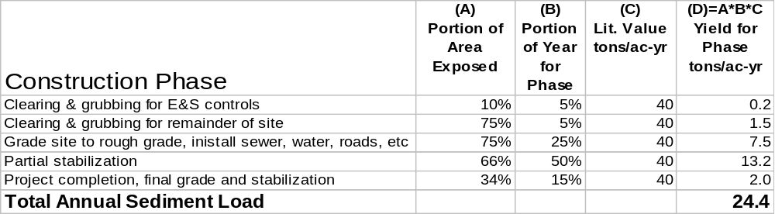

As described in Section 6, erosion and sediment control regulations, which were applied in different States at different times, have the effect of reducing the bare-construction erosion rate by an estimated 50% (Palace et al., 1998) after the erosion and storm water regulations are fully adopted and implemented. This level of reduction by E&S controls is further supported by Schueler (2007) who reports that the median turbidity from construction sites in Maryland drops from about 450 NTUs (range 4 to 8,200) and to a little more than 200 NTUs when effective E&S controls are applied.

The language of the Stormwater Phase II Rule directs States to “develop, implement, and enforce a program to reduce pollutants in any storm water runoff to from construction activities that result in a land disturbance of greater than or equal to one acre”. Erosion and sediment control legislation for construction activities were adopted by the States in the Phase 5 domain at different times between the early 1970s to the 1990s as described in Table 9.2.7.2. Estimated levels of effectiveness of the erosion and sediment (E&S) controls as described in Table 9.2.7.2 for the different States are applied over the Phase 5 simulation period of 1985 to 2005.

Table 9.2.7.2. Dates of erosion and sediment (E&S) control legislation in the States of the Phase 5 Model domain and estimates of relative effectiveness over time.

State | E & S Law Enacted | Regs adopted | Program Implementation | Recommended  Model Decision  Rules For E&S BMP
DE | 1973 | Early 1970’s & 1990 and various others | Although there were laws and regulations on the books from the early 1970s on, E & S plan review and enforcement were weak & scattered until 1991. In 1991 a functional, state-wide program started. Personal communications with Randy Greer, Div of Soil and Water, DNREC (302) 739-4411, March 2005. | From 1973 to 6/91: 25% sediment reduction  From 7/91 on: 50% sediment reduction
MD | 1970 | Early 1970’s, early ‘80’s, mid ‘90 | Small, state-wide enforcement of E & S from1970 on. Beginning in 1985, E & S state-wide program became fully functional. Personal communications with Jack Bowen, MDE (410) 537-3145, March 2005. | From 1970 to 3/84: 25% sediment reduction  From 4/84: 50% sediment reduction
PA | 1937 (Clean Streams Law) | 1972, 1998, 2002 | 1972 regs promulgated for all earth disturbances (ag, mining, construction, timber harvest etc.). Beginning in 1984 program became stronger and more effective. Personal communications with Ken Murin, PA DEP (717) 772-5975, March 2005. | 1972 – 1983: 25% sediment reduction  From 1984: 50% sediment reduction
DC | 1977 | Various | Small, district-wide program until significant improvement in 1994. In 1998 the program drastically improved again. Personal communications with Colin Burrell, DC DOH (202) 535-2240, March 2005. | 1977 to 1994: 25% sediment reduction  From 1994: 50% sediment reduction
VA | 1973 | 1977 & various | Small, less effective program until delegated E & S to counties in 1980.  Personal communications with Lee Hill VaDCR  (804) 786-3998, March 2005. | From 1973 to 6/80: 25% sediment reduction  From 7/80 on: 50% sediment reduction
WV | 1991 | 1991 | Late 1970’s state agencies addressed sediment control through a non-point source program which operated on a complaint basis only.  Phase I 1991, Phase II 2002. (Stated still operates mostly on a complaint basis.)  Bill Brannon 304-926-0499 ext. 1003, contacted 3/14/05 | From 1978 -1991: 15% sediment reduction  From 1991 on: 35% sediment reduction
NY | Early 1970’s | Early 1970’s, early/mid ‘90 | Prior to Phase I, E&S was more “reactive than proactive”.  NPDES Phase 1 Permit issued August 1, 1993. Phase 2 Permit issued January 8, 2003.  Peter Freehafer, (518) 402 –8272, contacted 3/14/05 | From 1973 – 1993: 25% sediment reduction  From 1993 on: 50% sediment reduction
KY | 1990 | 1991 | No erosion and sediment control program prior to NPDES  Phase I for construction sites, though industrial sites with other permits (KPDES) had their stormwater examined…Phase I 1991, MS4 1992, Phase II 2003,  Contact Jory Becker (502) 564-2225, ext 477, contacted 3/18/05. | From 1991on: 50% sediment reduction

9.2.8 Forest, Woodlots, and Wooded Areas
The Phase 5 forest land use covers woodland, woodlots, which are usually any wooded area of 30 m by 30 m which were remotely sensed by spectral analysis. The forest, woodlots, and wooded land use is the predominate land use in the Chesapeake watershed.

Forest estimates of EoF erosion rates from the Universal Soil Loss Equation (USLE) were provided by NRI in 1990 for model segments of a previous version (Phase 2) of the Watershed Model (Letter to Aqua Terra, 1990), but were unavailable for the more recent Phase 5 model development. Consequently, the previous NRI forest edge-of-field estimates of forest were used, transferring the values of the Phase 2 Model segments to the Phase 5 land segments (Table 9.2.14). The average forest EoF sediment load for the entire Phase 5 domain is 0.3 tons/acre, a value consistent with average literature values of EoF sediment loads.

Since the Phase 2 Watershed Model had a domain of only the Chesapeake Watershed, the Phase 5 expanded land areas in Virginia have no Phase 2 forest EoF erosion rates. For these areas standard techniques for applying USLE in forest lands were applied and the USLE and the results were scaled to match the range of the rest of the Chesapeake Bay watershed.

9.2.9 Harvested Forest
Harvested forests have higher erosion rates due to silviculture activities such as road building and movement of heavy equipment on forest soils (Arthur et al., 1998; Riekerk et al., 1998; Wilson et al., 1999; Grace, 2004; Hewlett, et al., 1979; Keppeler et al., 2003)). In addition, harvesting decreases interception storage and evapotranspiration, which also increases runoff. As Riekerk et al. (1988) relate, “Logging entails the cutting and skidding of trees. Cutting is done with power saws or by mechanical shearing with a feller-buncher. The later operation exposes and compacts soil, allowing more overland flow with its attendant erosion. Tree removal with rubber-tired or tracked skidders is most common and tends to disturb the soil most.”

Bare ground erosion rates of forest soils are typically estimated to be three to four orders of magnitude greater than that of base forest erosion rates. Current silviculture practice in the mid-Atlantic does not reduce forest soils to bare ground, but forest roads and harvest machinery bare some portion of harvested forest soils. The literature typically reports harvested forest erosion rates as being about an order of magnitude greater than undisturbed forest (Arthur et al., 1998; Riekerk et al., 1998; Perry, 1998). Accordingly, the Phase 5.1 harvested forest EoS erosion target is set at 3 tons/acre/year.

Table 9.2.2 Conventional till, conservation till, pasture, hay, and forest EoF sediment loading rates.

Sediment erosion edge-of-field targets derived from NRI estimates. Units in tons/acre.
 |  |  | Conventional | Conservation
 |  |  | Tillage Crop | Tillage Crop | Pasture | Hay | Forest
State | County | FIPS | (tons/ac) | (tons/ac) | (tons/ac) | (tons/ac) | (tons/ac)
Delaware | DE Kent | 10001 | 3.14 | 2.09 | 0.20 | 0.84 | 0.14
 | DE New Castle | 10003 | 4.33 | 2.89 | 0.80 | 1.16 | 0.17
 | DE Sussex | 10005 | 1.20 | 0.80 | 0.03 | 0.32 | 0.13
Maryland | MD Allegany | 24001 | 3.92 | 2.61 | 0.23 | 1.04 | 0.13
 | MD Anne Arundel | 24003 | 9.66 | 6.44 | 0.47 | 2.58 | 0.29
 | MD Baltimore | 24005 | 11.92 | 7.95 | 1.29 | 3.18 | 0.46
 | MD Calvert | 24009 | 21.26 | 14.18 | 1.15 | 5.67 | 0.30
 | MD Caroline | 24011 | 2.47 | 1.65 | 0.04 | 0.66 | 0.13
 | MD Carroll | 24013 | 3.93 | 2.62 | 0.85 | 1.05 | 0.34
 | MD Cecil | 24015 | 6.55 | 4.37 | 0.49 | 1.75 | 0.16
 | MD Charles | 24017 | 13.83 | 9.22 | 0.36 | 3.69 | 0.33
 | MD Dorchester | 24019 | 2.39 | 1.59 | 0.08 | 0.64 | 0.13
 | MD Frederick | 24021 | 9.21 | 6.14 | 1.48 | 2.46 | 0.32
 | MD Garrett | 24023 | 4.17 | 2.78 | 0.57 | 1.11 | 0.13
 | MD Harford | 24025 | 6.59 | 4.39 | 0.38 | 1.76 | 0.34
 | MD Howard | 24027 | 7.57 | 5.05 | 3.20 | 2.02 | 0.50
 | MD Kent | 24029 | 5.36 | 3.57 | 1.27 | 1.43 | 0.17
 | MD Montgomery | 24031 | 10.52 | 7.01 | 1.23 | 2.80 | 0.36
 | MD Prince Georges | 24033 | 21.39 | 14.26 | 2.99 | 5.70 | 0.34
 | MD Queen Annes | 24035 | 4.16 | 2.77 | 0.16 | 1.11 | 0.17
 | MD St Marys | 24037 | 7.52 | 5.01 | 0.28 | 2.00 | 0.33
 | MD Somerset | 24039 | 2.01 | 1.34 | 0.03 | 0.54 | 0.13
 | MD Talbot | 24041 | 2.09 | 1.39 | 0.03 | 0.56 | 0.13
 | MD Washington | 24043 | 5.99 | 3.99 | 1.28 | 1.60 | 0.31
 | MD Wicomico | 24045 | 2.69 | 1.79 | 0.16 | 0.72 | 0.13
 | MD Worcester | 24047 | 3.02 | 2.01 | 0.27 | 0.80 | 0.13
New York | NY Allegany | 36003 | 2.53 | 1.69 | 0.98 | 0.67 | 0.27
 | NY Broome | 36007 | 2.46 | 1.64 | 0.17 | 0.66 | 0.27
 | NY Cayuga | 36011 | 3.55 | 2.37 | 0.34 | 0.95 | NA
 | NY Chemung | 36015 | 3.94 | 2.63 | 0.57 | 1.05 | 0.27
 | NY Chenango | 36017 | 4.28 | 2.86 | 0.38 | 1.14 | 0.27
 | NY Cortland | 36023 | 3.01 | 2.01 | 0.18 | 0.80 | 0.27
 | NY Delaware | 36025 | 3.30 | 2.20 | 0.41 | 0.88 | 0.27
 | NY Herkimer | 36043 | 5.40 | 3.60 | 0.31 | 1.44 | 0.27
 | NY Livingston | 36051 | 4.76 | 3.17 | 0.55 | 1.27 | 0.27
 | NY Madison | 36053 | 4.20 | 2.80 | 0.17 | 1.12 | 0.27
 | NY Oneida | 36065 | 3.84 | 2.56 | 0.22 | 1.03 | 0.27
 | NY Onondaga | 36067 | 3.40 | 2.27 | 0.08 | 0.91 | 0.27
 | NY Ontario | 36069 | 3.13 | 2.08 | 1.00 | 0.83 | 0.27
 | NY Otsego | 36077 | 3.89 | 2.59 | 2.32 | 1.04 | 0.27
 | NY Schoharie | 36095 | 3.74 | 2.49 | 0.35 | 1.00 | 0.27
 | NY Schuyler | 36097 | 1.89 | 1.26 | 0.42 | 0.50 | 0.27
 | NY Steuben | 36101 | 3.67 | 2.44 | 0.29 | 0.98 | 0.27
 | NY Tioga | 36107 | 1.91 | 1.28 | 0.55 | 0.51 | 0.27
 | NY Tompkins | 36109 | 2.10 | 1.40 | 0.11 | 0.56 | 0.27
 | NY Yates | 36123 | 3.86 | 2.57 | 0.46 | 1.03 | 0.27
North Carolina | NC Alamance | 37001 | 17.91 | 11.94 | 0.17 | 4.78 | 0.19
 | NC Alleghany | 37005 | 8.36 | 5.58 | 0.85 | 2.23 | 0.38
 | NC Ashe | 37009 | 6.29 | 4.19 | 3.00 | 1.68 | 0.47
 | NC Caswell | 37033 | 8.72 | 5.82 | 0.18 | 2.33 | 0.20
 | NC Forsyth | 37067 | 17.00 | 11.33 | 1.80 | 4.53 | 0.20
 | NC Granville | 37077 | 12.37 | 8.24 | 1.67 | 3.30 | 0.16
 | NC Guilford | 37081 | 7.50 | 5.00 | 0.14 | 2.00 | 0.21
 | NC Northampton | 37131 | 4.93 | 3.29 | 0.07 | 1.32 | 0.14
 | NC Orange | 37135 | 7.62 | 5.08 | 0.24 | 2.03 | 0.21
 | NC Person | 37145 | 11.62 | 7.75 | 0.30 | 3.10 | 0.19
 | NC Rockingham | 37157 | 9.84 | 6.56 | 2.82 | 2.62 | 0.20
 | NC Stokes | 37169 | 23.50 | 15.66 | 0.33 | 6.27 | 0.23
 | NC Surry | 37171 | 13.35 | 8.90 | 0.39 | 3.56 | 0.27
 | NC Vance | 37181 | 11.07 | 7.38 | 0.57 | 2.95 | 0.18
 | NC Warren | 37185 | 14.29 | 9.53 | 1.68 | 3.81 | 0.22
 | NC Watauga | 37189 | 16.95 | 11.30 | 3.22 | 4.52 | 0.44
Pennsylvania | PA Adams | 42001 | 5.38 | 3.59 | 0.17 | 1.44 | 0.27
 | PA Bedford | 42009 | 5.51 | 3.67 | 1.08 | 1.47 | 0.27
 | PA Berks | 42011 | 8.06 | 5.37 | 0.74 | 2.15 | 0.33
 | PA Blair | 42013 | 4.16 | 2.77 | 0.21 | 1.11 | 0.33
 | PA Bradford | 42015 | 5.53 | 3.69 | 0.23 | 1.48 | 0.31
 | PA Cambria | 42021 | 3.74 | 2.50 | 0.22 | 1.00 | 0.33
 | PA Cameron | 42023 | NA | NA | 0.29 | NA | 0.33
 | PA Carbon | 42025 | 4.44 | 2.96 | 0.54 | 1.18 | 0.33
 | PA Centre | 42027 | 7.17 | 4.78 | 1.41 | 1.91 | 0.33
 | PA Chester | 42029 | 8.88 | 5.92 | 0.49 | 2.37 | 0.18
 | PA Clearfield | 42033 | 0.99 | 0.66 | 4.53 | 0.26 | 0.33
 | PA Clinton | 42035 | 3.36 | 2.24 | 0.65 | 0.90 | 0.33
 | PA Columbia | 42037 | 5.51 | 3.67 | 0.40 | 1.47 | 0.33
 | PA Cumberland | 42041 | 7.21 | 4.81 | 1.22 | 1.92 | 0.33
 | PA Dauphin | 42043 | 5.06 | 3.37 | 0.31 | 1.35 | 0.33
 | PA Elk | 42047 | 0.96 | 0.64 | 0.22 | 0.26 | 0.33
 | PA Franklin | 42055 | 7.50 | 5.00 | 0.74 | 2.00 | 0.33
 | PA Fulton | 42057 | 3.27 | 2.18 | 1.77 | 0.87 | 0.32
 | PA Huntingdon | 42061 | 6.90 | 4.60 | 0.55 | 1.84 | 0.33
 | PA Indiana | 42063 | 2.41 | 1.61 | 1.30 | 0.64 | 0.33
 | PA Jefferson | 42065 | 4.01 | 2.67 | 1.00 | 1.07 | 0.33
 | PA Juniata | 42067 | 5.93 | 3.95 | 0.36 | 1.58 | 0.33
 | PA Lackawanna | 42069 | 2.04 | 1.36 | 0.53 | 0.55 | 0.33
 | PA Lancaster | 42071 | 9.63 | 6.42 | 1.65 | 2.57 | 0.30
 | PA Lebanon | 42075 | 8.11 | 5.40 | 0.46 | 2.16 | 0.33
 | PA Luzerne | 42079 | 3.29 | 2.20 | 0.15 | 0.88 | 0.33
 | PA Lycoming | 42081 | 6.80 | 4.53 | 0.26 | 1.81 | 0.33
 | PA McKean | 42083 | 0.52 | 0.34 | 0.03 | 0.14 | 0.33
 | PA Mifflin | 42087 | 6.23 | 4.15 | 0.27 | 1.66 | 0.33
 | PA Montour | 42093 | 10.83 | 7.22 | 0.20 | 2.89 | 0.33
 | PA Northumberland | 42097 | 9.63 | 6.42 | 0.81 | 2.57 | 0.33
 | PA Perry | 42099 | 5.19 | 3.46 | 1.36 | 1.38 | 0.33
 | PA Potter | 42105 | 3.04 | 2.03 | 0.49 | 0.81 | 0.33
 | PA Schuylkill | 42107 | 6.63 | 4.42 | 0.54 | 1.77 | 0.33
 | PA Snyder | 42109 | 6.87 | 4.58 | 10.08 | 1.83 | 0.33
 | PA Somerset | 42111 | 3.57 | 2.38 | 1.21 | 0.95 | 0.17
 | PA Sullivan | 42113 | 1.59 | 1.06 | 0.91 | 0.42 | 0.33
 | PA Susquehanna | 42115 | 0.98 | 0.65 | 0.16 | 0.26 | 0.31
 | PA Tioga | 42117 | 4.12 | 2.75 | 0.60 | 1.10 | 0.30
 | PA Union | 42119 | 5.35 | 3.57 | 0.08 | 1.43 | 0.33
 | PA Wayne | 42127 | 0.63 | 0.42 | 0.12 | 0.17 | 0.30
 | PA Wyoming | 42131 | 5.04 | 3.36 | 0.18 | 1.34 | 0.33
 | PA York | 42133 | 10.84 | 7.23 | 0.31 | 2.89 | 0.30
 | TN Johnson | 47091 | 2.38 | 1.59 | 0.40 | 0.63 | 0.46
 | TN Sullivan | 47163 | 11.80 | 7.86 | 1.28 | 3.15 | 0.60
Virginia | VA Accomack | 51001 | 2.13 | 1.42 | 0.04 | 0.57 | 0.13
 | VA Albemarle | 51003 | 1.00 | 0.67 | 2.85 | 0.27 | 0.25
 | VA Alleghany | 51005 | 0.09 | 0.06 | 1.54 | 0.02 | 0.35
 | VA Amelia | 51007 | 11.77 | 7.85 | 0.90 | 3.14 | 0.18
 | VA Amherst | 51009 | 3.00 | 2.00 | 3.45 | 0.80 | 0.26
 | VA Appomattox | 51011 | 4.83 | 3.22 | 1.83 | 1.29 | 0.25
 | VA Augusta | 51015 | 12.03 | 8.02 | 3.74 | 3.21 | 0.21
 | VA Bath | 51017 | 0.72 | 0.48 | 1.51 | 0.19 | 0.38
 | A Bedford | 51019 | 3.32 | 2.21 | 4.54 | 0.89 | 0.38
 | VA Bland | 51021 | 2.09 | 1.39 | 8.36 | 0.56 | 0.36
 | A Botetourt | 51023 | 8.12 | 5.42 | 6.85 | 2.17 | 0.33
 | A Brunswick | 51025 | 9.68 | 6.45 | 1.83 | 2.58 | 0.19
 | VA Buchanan | 51027 | 2.03 | 1.35 | 3.40 | 0.54 | 0.48
 | A Buckingham | 51029 | 3.63 | 2.42 | 1.97 | 0.97 | 0.22
 | VA Campbell | 51031 | 3.72 | 2.48 | 1.08 | 0.99 | 0.22
 | VA Caroline | 51033 | 4.72 | 3.15 | 0.09 | 1.26 | 0.17
 | VA Carroll | 51035 | 10.10 | 6.73 | 3.52 | 2.69 | 0.26
 | VA Charles City | 51036 | 4.21 | 2.81 | 0.19 | 1.12 | 0.15
 | VA Charlotte | 51037 | 5.14 | 3.43 | 1.33 | 1.37 | 0.20
 | VA Chesterfield | 51041 | 5.67 | 3.78 | 0.28 | 1.51 | 0.16
 | VA Clarke | 51043 | 2.06 | 1.37 | 0.67 | 0.55 | 0.23
 | VA Craig | 51045 | 3.65 | 2.43 | 1.95 | 0.97 | 0.32
 | VA Culpeper | 51047 | 8.59 | 5.73 | 1.71 | 2.29 | 0.20
 | VA Cumberland | 51049 | 3.44 | 2.29 | 1.03 | 0.92 | 0.18
 | VA Dickenson | 51051 | 8.32 | 5.55 | 3.85 | 2.22 | 0.40
 | VA Dinwiddie | 51053 | 12.07 | 8.05 | 1.29 | 3.22 | 0.16
 | VA Essex | 51057 | 5.98 | 3.99 | 0.22 | 1.59 | 0.18
 | VA Fairfax | 51059 | 5.07 | 3.38 | 1.32 | 1.35 | 0.20
 | VA Fauquier | 51061 | 4.59 | 3.06 | 0.73 | 1.22 | 0.21
 | VA Floyd | 51063 | 1.96 | 1.31 | 1.50 | 0.52 | 0.25
 | VA Fluvanna | 51065 | 2.44 | 1.62 | 0.66 | 0.65 | 0.21
 | VA Franklin | 51067 | 7.56 | 5.04 | 2.77 | 2.01 | 0.23
 | VA Frederick | 51069 | 4.03 | 2.69 | 0.88 | 1.07 | 0.24
 | VA Giles | 51071 | 0.11 | 0.07 | 0.48 | 0.03 | 0.36
 | VA Gloucester | 51073 | 4.43 | 2.95 | 0.18 | 1.18 | 0.18
 | VA Goochland | 51075 | 1.69 | 1.13 | 0.50 | 0.45 | 0.19
 | VA Grayson | 51077 | 3.52 | 2.35 | 3.22 | 0.94 | 0.26
 | VA Greene | 51079 | 4.58 | 3.05 | 1.24 | 1.22 | 0.21
 | VA Greensville | 51081 | 6.98 | 4.65 | 0.08 | 1.86 | 0.15
 | VA Halifax | 51083 | 8.49 | 5.66 | 1.62 | 2.26 | 0.20
 | VA Hanover | 51085 | 6.79 | 4.53 | 3.58 | 1.81 | 0.16
 | VA Henrico | 51087 | 6.14 | 4.09 | 0.24 | 1.64 | 0.14
 | VA Henry | 51089 | 9.19 | 6.13 | 2.04 | 2.45 | 0.25
 | VA Highland | 51091 | 0.40 | 0.27 | 5.50 | 0.11 | 0.34
 | VA Isle of Wight | 51093 | 5.83 | 3.88 | 0.05 | 1.55 | 0.14
 | VA James City | 51095 | 5.68 | 3.79 | 0.64 | 1.51 | 0.17
 | VA King and Queen | 51097 | 3.91 | 2.61 | 10.85 | 1.04 | 0.16
 | VA King George | 51099 | 2.35 | 1.57 | 1.68 | 0.63 | 0.18
 | VA King William | 51101 | 5.06 | 3.37 | 0.39 | 1.35 | 0.19
 | VA Lancaster | 51103 | 0.77 | 0.51 | 0.16 | 0.20 | 0.20
 | VA Lee | 51105 | 7.98 | 5.32 | 7.96 | 2.13 | 0.39
 | VA Loudoun | 51107 | 4.99 | 3.32 | 0.66 | 1.33 | 0.19
 | VA Louisa | 51109 | 4.31 | 2.88 | 0.27 | 1.15 | 0.18
 | VA Lunenburg | 51111 | 12.84 | 8.56 | 1.32 | 3.42 | 0.19
 | VA Madison | 51113 | 10.32 | 6.88 | 1.54 | 2.75 | 0.23
 | VA Mathews | 51115 | 1.95 | 1.30 | 0.07 | 0.52 | 0.14
 | VA Mecklenburg | 51117 | 12.80 | 8.53 | 1.23 | 3.41 | 0.20
 | VA Middlesex | 51119 | 5.90 | 3.93 | 0.09 | 1.57 | 0.18
 | VA Montgomery | 51121 | 8.12 | 5.41 | 7.07 | 2.16 | 0.34
 | VA Nelson | 51125 | 7.55 | 5.03 | 2.34 | 2.01 | 0.30
 | VA New Kent | 51127 | 4.91 | 3.27 | NA | 1.31 | 0.19
 | VA Northampton | 51131 | 2.16 | 1.44 | NA | 0.58 | 0.13
 | VA Northumberland | 51133 | 4.16 | 2.77 | 1.26 | 1.11 | 0.20
 | VA Nottoway | 51135 | 8.66 | 5.77 | 0.76 | 2.31 | 0.19
 | VA Orange | 51137 | 6.97 | 4.64 | 1.66 | 1.86 | 0.20
 | VA Page | 51139 | 7.31 | 4.87 | 0.89 | 1.95 | 0.30
 | VA Patrick | 51141 | 8.67 | 5.78 | 3.75 | 2.31 | 0.26
 | VA Pittsylvania | 51143 | 10.80 | 7.20 | 1.62 | 2.88 | 0.19
 | VA Powhatan | 51145 | 2.97 | 1.98 | 0.32 | 0.79 | 0.19
 | VA Prince Edward | 51147 | 4.35 | 2.90 | 0.97 | 1.16 | 0.19
 | VA Prince George | 51149 | 8.44 | 5.62 | 0.64 | 2.25 | 0.15
 | VA Prince William | 51153 | 3.44 | 2.29 | 0.34 | 0.92 | 0.18
 | VA Pulaski | 51155 | 2.72 | 1.81 | 2.14 | 0.73 | 0.35
 | VA Rappahannock | 51157 | 14.29 | 9.53 | 0.83 | 3.81 | 0.25
 | VA Richmond | 51159 | 0.89 | 0.59 | 3.73 | 0.24 | 0.16
 | VA Roanoke | 51161 | 6.78 | 4.52 | 3.13 | 1.81 | 0.60
 | VA Rockbridge | 51163 | 6.95 | 4.63 | 9.90 | 1.85 | 0.34
 | VA Rockingham | 51165 | 10.62 | 7.08 | 3.56 | 2.83 | 0.24
 | VA Russell | 51167 | 5.19 | 3.46 | 8.93 | 1.38 | 0.50
 | VA Scott | 51169 | 3.46 | 2.31 | 11.50 | 0.92 | 0.46
 | VA Shenandoah | 51171 | 7.86 | 5.24 | 3.20 | 2.10 | 0.27
 | VA Smyth | 51173 | 2.84 | 1.89 | 4.85 | 0.76 | 0.39
 | VA Southampton | 51175 | 5.18 | 3.46 | 0.38 | 1.38 | 0.14
 | VA Spotsylvania | 51177 | 5.30 | 3.54 | 0.89 | 1.41 | 0.17
 | VA Stafford | 51179 | 12.02 | 8.01 | 1.48 | 3.20 | 0.19
 | VA Surry | 51181 | 6.99 | 4.66 | 0.26 | 1.86 | 0.16
 | VA Sussex | 51183 | 7.02 | 4.68 | 0.09 | 1.87 | 0.14
 | VA Tazewell | 51185 | 5.36 | 3.57 | 10.24 | 1.43 | 0.45
 | VA Warren | 51187 | 7.22 | 4.81 | 1.31 | 1.92 | 0.47
 | VA Washington | 51191 | 7.85 | 5.23 | 8.09 | 2.09 | 0.44
 | VA Westmoreland | 51193 | 1.14 | 0.76 | 2.01 | 0.30 | 0.16
 | VA Wise | 51195 | 0.50 | 0.33 | 4.84 | 0.13 | 0.39
 | VA Wythe | 51197 | 3.23 | 2.15 | 2.38 | 0.86 | 0.34
 | VA York | 51199 | 3.58 | 2.38 | NA | 0.95 | 0.15
 | VA Chesapeake City | 51550 | 2.47 | 1.65 | 0.02 | 0.66 | 0.13
 | VA Falls Church City | 51610 | NA | NA | NA | NA | 0.33
 | VA Lynchburg City | 51680 | NA | NA | 0.06 | NA | 0.24
 | VA Norfolk City | 51710 | NA | NA | NA | NA | 0.14
 | VA Portsmouth City | 51740 | NA | NA | NA | NA | 0.14
 | VA Richmond City | 51760 | NA | NA | NA | NA | 0.16
 | VA Suffolk City | 51800 | 3.57 | 2.38 | 0.06 | 0.95 | 0.13
 | VA Virginia Beach City | 51810 | 2.24 | 1.50 | 0.09 | 0.60 | 0.13
West Virginia | WV Berkeley | 54003 | 2.35 | 1.57 | 0.33 | 0.63 | 0.33
 | WV Grant | 54023 | 0.82 | 0.55 | 2.82 | 0.22 | 0.13
 | WV Hampshire | 54027 | 1.39 | 0.93 | 1.74 | 0.37 | 0.13
 | WV Hardy | 54031 | 1.79 | 1.19 | 1.87 | 0.48 | 0.15
 | WV Jefferson | 54037 | 2.12 | 1.41 | 0.28 | 0.57 | 0.40
 | WV McDowell | 54047 | 11.29 | 7.53 | 3.59 | 3.01 | NA
 | WV Mineral | 54057 | 0.66 | 0.44 | 1.87 | 0.18 | 0.13
 | WV Monroe | 54063 | 8.10 | 5.40 | 6.44 | 2.16 | 0.60
 | WV Morgan | 54065 | 10.08 | 6.72 | 1.36 | 2.69 | 0.24
 | WV Pendleton | 54071 | 1.36 | 0.90 | 1.55 | 0.36 | 0.13
 | WV Preston | 54077 | 7.63 | 5.09 | 1.60 | 2.04 | 0.13
 | WV Tucker | 54093 | 0.13 | 0.09 | 2.25 | 0.03 | 0.13
Average |  |  | 5.7878 | 3.8585 | 1.5502 | 1.5434 | 0.2591
Standard Deviation |  |  | 4.0475 | 2.6984 | 2.1390 | 1.0793 | 0.0989
Maximum |  |  | 23.4954 | 15.6636 | 11.5045 | 6.2654 | 0.6000
Minimum |  |  | 0.0900 | 0.0600 | 0.0215 | 0.0240 | 0.1300

9.2.11 Extractive – Active and Abandoned Mines
The extractive land use is comprised of mines, gravel pits, and the like. Federal and State laws in the early 1980's regulated active working mines and applied effluent limits of about 70 mg/l TSS to discharges from mines. Abandoned mines have, of course, no effluent limits. Consistent with the level of information available, extractive land south of the confluence of the West Branch and Susquehanna Rivers is considered to be active mines with an effluent limit applied (Personal Communication: telephone call with Don Fiesta, August 9, 2004). Assuming precipitation of 40 inches/year, annual evaporation and other losses of 50%, and effluent limits of 70 mg/l, the sediment loading rate for regulated active mines is estimated to be 0.16 tons/acre-year.

Areas of extractive land use north of the confluence of the West Branch and Susquehanna are assumed to be largely waste piles and abandoned mine areas (Personal Communication: telephone call with Don Fiesta, August 9, 2004). These areas of mines, and waste piles are characterized as largely unvegetated, with relatively little groundwater, and in fractured ground. This is particularly true for waste and product piles. The hydrology of these areas after a rainfall event is described as an initial slight loss due to evaporation from surface storage and roughness, followed by the majority of the water acting like interflow with the flow slowing and ending after a number of days. In this sense the waste and product piles act as a slightly porous sponge with water percolating though the pile slowly over a period of days. For these areas, the estimated EoF erosion rates for the extractive land use are arbitrarily set (in the absence of available literature values) at 10 tons/acre-yr, a value one-quarter that of bare-construction land use sediment load estimates.

9.2.12 Nurseries – Container Nurseries
As discussed in Section 4 the nursery land use is comprised of field nurseries and container nurseries. The Agricultural Census is the source of area estimates for these two nursery types. Field nurseries have characteristics similar to conventional tillage without manure and is included within that land use. Container nurseries are simulated separately and are simulated as primarily a source of nutrients, but not of sediment. Therefore the estimated sediment loads from container nurseries is set to be equal to that of natural grass.

9.2.13 Open Water – Rivers, Reservoirs, and Other Water Surfaces
Aeolian, or atmospheric deposition, sources of sediment are slight, yet make a small contribution to the overall mass balance. Aeolian sediment is from fine material blown off land surfaces onto open water land use areas. While land surfaces also have an aeolian input of sediment, there’s also an aeolian reduction, and the overall net aeolian input to land surfaces is assumed to be zero. For water surfaces, Langland and Cronin (2003) estimate atmospheric deposition to be 1.15 grams/m² yr, or 5.13 x 10⁻³ tons/acre-year. This is simulated as a constant daily input to water surfaces.

9.2.11 Comparison of Edge-of-Field Sediment Load Rates
Table 9.2.2 lists the different land uses and estimated EoF sediment loads. The estimated loads in Table 9.2.2 are base loads and are reduced by the application of State reported levels of BMPs as described in Section 6.

Table 9.2.2. Overall estimated sediment erosion rate targets for different land uses.

EoF Sediment
Loading Rate
Land Use (tons/acre-year) Source
Conventional Tillage Crop 5.8 adjusted NRI average (1982-1987)
Conservation Tillage Crop 3.9 adjusted NRI average (1982-1987)
Hay 1.5 adjusted NRI average (1982-1987)
Pasture 1.6 NRI average (1982-1987)
Degraded Stream Corridor 15.2 NRI pasture average (1982-1987) * 9.5
Developed – Pervious (0%)
Developed – Impervious (100%)
Industrial (90%I) 4.7 regression
Commercial (80%I) 4.3 regression
Highway (50%I) 3.0 regression
High Density Res. (35%I) 2.3 regression
Med Density Res. (25%I) 1.8 regression
Low Density Res. (15%I) 1.4 regression
Park/Recreational Area (2%I) 0.8 regression
Bare-Construction (no BMP) 24.0 literature values
Bare-Construction (with E&S) 12.0 literature values
Forest-Woodlots-Wooded areas 0.3 NRI (1987)
Harvested Forest 3.0 literature values
Natural Grass 1.5 NRI average (1982-1997)
Extractive (uncontrolled) 10.0 literature values/best professional judgment
Extractive (controlled) 0.2 calculated from active mine effluent limits
Water 0.005 literature values

9.3 Edge-of-Field Sediment Calibration Rules
HSPF simulates erosion from the land surface by simulating three processes: 1) detachment of soil by rainfall, wind or human activities; 2) removal of detached soil by runoff; and 3) reattachment of detached soil to the soil matrix. Table 9.3.1 shows the parameters that control the simulation of these processes.

Table 9.3.1. Key Parameters in Sediment Calibration on Land Segments.

Parameter | Description
NVSI | Rate at which sediment is added to detached soil from atmosphere; Negative values can simulate removal of sediment by wind or human activities.
KRER | Coefficient which determines how much sediment is detaches from the soil matrix as a function of rainfall.
COVER | Fraction of soil surface in vegetative cover and unavailable for erosion; COVER varies monthly by land use.
AFFIX | Rate at which detached sediment is re-attached to soil matrix.
KSER | Coefficient which determines how much detached sediment is eroded as a function of rainfall.

An iterative calibration program was developed to calibrate each land use type to the target values. Developing an automated calibration procedure is necessary given the large number of EoF target loads. The number of Phase 5 EoF sediment loads to be calibrated is 7700 from the 25 land uses and 308 land-segments. Since there are four parameters (COVER derived from data) but only one calibration target for each land use/segment pair, three calibration rules were set up to regulate these four parameters, in order to reduce the number of parameters to be calibrated so that an iterative calibration procedure can be operationally feasible.

The automated calibration starts from the parameter set from manual calibration and adjusts parameters based on model output according to the following three calibration rules:

- Ninety percent of detached sediment is re-attached to the soil in 30 days. Detached sediment decreases each day as a result of soil compaction on days without rainfall. Detached sediment storage tends to gradually reach its maximum value and stay at a stable status over time (Figure 9.3.1). This rule is used in an attempt to reflect this natural property of sediment dynamic by regulating the behavior of AFFIX. This constraint is met by setting the first-order re-attachment rate, AFFIX, to 0.07675/day for all land uses/all segments.

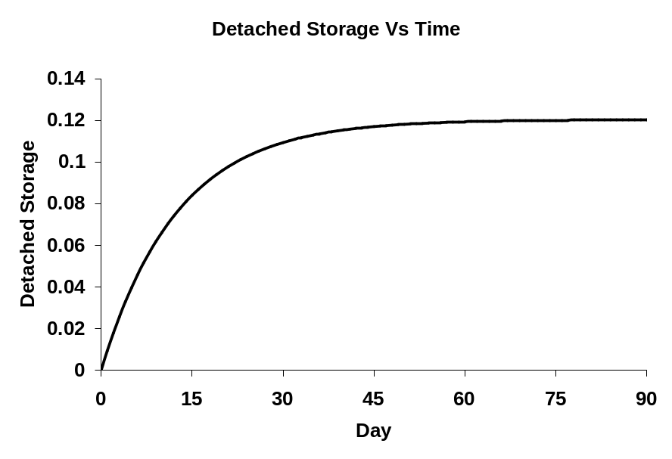

Figure 9.3.1. The dynamic of detached storage over time.

- NSVI should be set high enough that sediment concentrations during storms are larger on the rising limb of the hydrograph than the falling limb (the hysteresis effect). It has been observed that sediment concentrations during storms are larger as water is rising than when water levels are falling. This is attributed to the fact that as water rises, previously detached sediment is removed until storage is depleted. [REFERENCE THIS]

To mimic this hysteresis effect, NVSI is used in the Phase 5 Model to increase the detached sediment storage, so there is a sufficient supply before each storm event. Within this context, NVSI represents any net additions or removal of detached sediment by human activities or wind on a daily-basis, other than standard HSPF definition. Mathematically, the rule can be expressed as:

NVSI *365 = a*Target loads

where a is the significant fraction that related NVSI to total target loads, and it was determined together with the specification of KSER/KRER ratio, as discussed below.

- There should be no detached sediment in storage after large storms. Generally, large storms should flush watersheds of detached sediment three of four times a year. Sediment storage is typically depleted during storm events and on a seasonal time scale (Van Sickle and Beschta 1983). The qualitative effects of changing sediment supplies are reflected in the decreasing sediment concentrations at a specific discharge level with time during a single storm event, as well as on a seasonal time scale as the runoff season progresses and sediment are flushed from the watershed. The phenomena of seasonal decline and storm hysteresis are apparent in streams of all sizes
From a long-term perspective, the accumulated sediment on the land surface should not be continually increasing or decreasing (Allen Gellis, personal communication 2004).

This rule is developed to reproduce the sediment dynamics of storm hysteresis and of seasonal decline. The rule has important management implications, particularly for agriculture. Cropland is generally plowed two or three times a year during planting season in spring and harvesting season in fall. During these periods, the soil is loosened from land and added to detached storage available for washoff. As a result, sediment loadings from agriculture land typically increase at these times due to increased sediment supply, consistent with numerous field observations. To capture the impact of plowing on sediment loading as well as the effects of stormwater management strategies for erosion control, the simulated sediment storage needs to go down to zero so that sediment supply will become storage limited.

This rule is enforced by adjusting
KRER and KSER within their minimum and maximum values. To further reduce the parameter set, a proportional relationship between KSER and KRER was assumed:

KSER = b* KRER

A strategy was developed to optimize the ratio a and b together. In light of numerous possible combinations that these two ratios could formulate, best engineering judgment was excised to formulate a set of 20 combinations that are physically meaningful and operationally feasible. The feasibility of each scenario was tested, first with land simulation and then river simulation. Among them, the scenario with the significant fraction a of 1.5 and the ratio of KSER: KRER of 5 gives the slight better correlations, and produces relative low average detached storage, and was therefore chosen as the final solution. NVSI can then be determined for each land use within each county based on their NRI targets, and KSER values are kept as 5 times of KRER values.

Once the ratio a and b is specified, the iterative calibration process was carried out to adjust KSER based on model outputs to ensure that simulated EOF loads reach to the target loads, as well as appropriate hysteresis in washoff and appropriate response to high rainfall events.

9.4 Sediment Transport to Edge-of-Stream
Edge-of-stream (EoS) loads are defined as the loads that enter the river reaches represented in the model. They represent not only the erosion from the land but all of the intervening processes of deposition on hillsides and sediment transport through smaller rivers and streams that are not represented in the Phase 5 Model. The influence of the sum of these processes is contained within the estimated sediment delivery ratio, which represents the ratio between sediment transported at a watershed outlet and erosion generated in the watershed. The EoS load for a reach is therefore the integration of sediment load scour, transport, storage, and fate from all smaller watersheds and streams unrepresented in the model

Delivery of sediment to the EoS is in the portions of sand, silt, and clay is based on the STASGO county level assessment of the percent sand silt and clay in the soils. The portion of sand is discounted by an order of magnitude due to the greater portion of delivery of fines relative to the sand and gravels from the EoF to the EoS. This has the effect of an average portion of sand delivered to the EoS from the EoF to be about 4%, which is consistent with Phase 4.3 sand delivery to EoS.

As EoF loads are transported sequentially through model segments, loss occurs due to depositional processes that occur in overland flow prior to reaching a stream channel as well as in low order streams. These low order streams are not explicitly simulated in the Phase 5 simulation. Therefore, it is necessary to use a delivery factor to reduce the EoF erosion rates if they are to be used to represent edge-of-stream (EoS) erosion rates. This fraction of sediment that is available for delivery to the EoS is referred to as the delivery factor (DF). This factor is multiplied by the predicted EoF erosion rate to estimate the eroded sediments actually delivered to a specific reach. Several approaches are available for calculating a delivery factor translating edge-of-field sediment loads to edge-of stream (Sun and Mcnulty, 1998; Yagow, 1988; SCS, 1983; Swift, 2000)

The base formula for calculating sediment delivery ratios in the Phase 5 Model is

DF = 0.417762 * A -0.134958 - 0.127097

Where DF is the sediment delivery ratio and A is drainage area in square miles. The use of this formula was standard practice for the NRCS (SCS, 1983) and it was also used in earlier versions of the Watershed Model. In the Phase 5 Model, the sediment delivery ratio was calculated by land use and river segment, in order to take into account the fact that land uses may differ in how they are situated with respect to river reaches. In the Ridge and Valley region, for example, the bottom of the valleys is more likely to be cultivated, while because of steep slopes, hillslopes are forested or used for pasture. To take this into account, land use-specific sediment delivery ratios were calculated for each river segment, using the following procedure: (1) In GIS, the mean distance between the parcels of a river segment in a land use and the river reach was calculated; (2) the sediment delivery ratio for that land used was calculated by assuming that the area in the DF formula is equal to a circle with radius equal to the mean distance between the land use and the river reach. Table 16 gives the average DF for each eight-digit watershed by land use. The average is taken over the Phase 5 river segments that make up the eight-digit watershed.

A single factor for each land use in each segment was calculated using SCS method. The factor is related to watershed size and unique for each land use. The drainage area in the equation was estimated by assuming the area is a circle and the mean distance from land to river is the radius. The mean distance from a land use to a particular river was calculated using GIS tools. To derive a unique delivery factor for each land use in each segment, the average distance to stream for a given land use in a segment is conceived as the radius of a circle, giving a sense of the heuristic nature of the actual, but unknown distance to low order streams and overall efficiency of sediment transport. The area of that circle is used to calculate the delivery factor for that land use using the equation above.

Using the above sediment target loads and delivery factors the EoS loads were generated and used in the riverine calibration of sediment to observed values at monitoring stations. Since scour and deposition are calibrated in the river reaches, there is a check on these EoS sediment loads in all provinces except for the province of the coastal plain.

The coastal plain physiographic region simulated in Phase 5 has few monitoring stations and the calibration of the EoS sediment loads as is done in the other physiographic regions is unachievable in the coastal plain except for a few river reaches. For this region, a separate analysis was done relating the EoF sediment loads to the load estimates at the monitoring stations using the Estimator regression model (Curry, 2006). This analysis found that the EoF to EoS transport factors in the coastal plain was about one quarter that of the Appalachian Highland and Ridge and Valley physiographic regions. This may be related to the “competency” of rivers to transport of sediment loads and the low gradients of the Coastal Plain region (Figure 9.4.1), and is consistent with our understanding of sediment behavior in watersheds. The low gradient of the coastal plain delivers relatively less sediment loads than the higher gradient physiographic regions. Based on this analysis the sediment delivery factors in the coastal plain were multiplied by a factor of 0.25. The other physiographic regions were unadjusted because the sediment monitoring stations allowed a calibration of the EoS sediment loads. This is true even in the case of the Piedmont province where the application of a methodology to discern estimates of legacy sediment loads from erosion form the land is applied as described in Section 9.5.

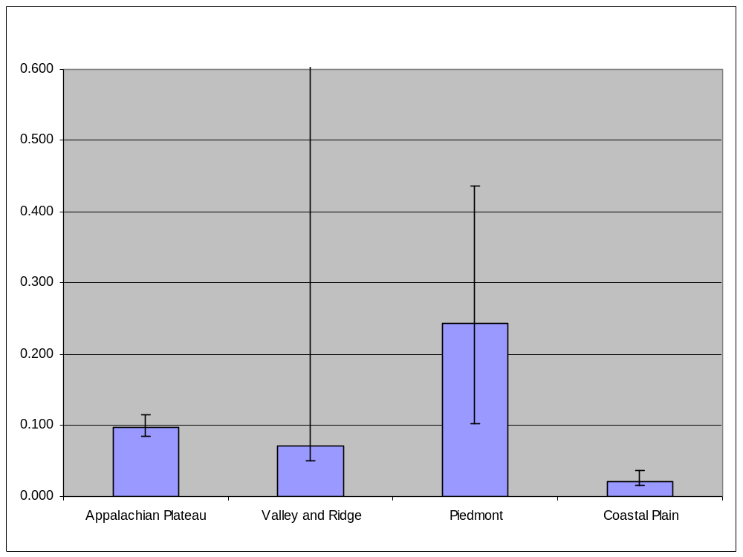
Figure 9.4.1. The median, 25th percentile, and 75th percentile estimates of the sediment delivery ratio for major physiographic regions of the Chesapeake.

In Phase 5 only a single sediment size fraction is simulated at the edge-of field, but when loading sediment to the edge-of-stream, a sand, silt, and clay fraction is required. To best represent sediment loads we assumed the edge-of-field load is best represented in each land-segment by the STASTGO assessment of percent sand in the land-segment soils (Schwarz, G.E. and Alexander, 1995). The STASGO percent sand, silt and clay is what’s assumed to be eroded at the edge-of-field and the edge-of-stream percent sand is assumed to be an order of magnitude less than this. This varies from land-segment to land-segment but on average is about 5% sand. The edge-of-stream silt and clay are adjusted proportionately.

9.5 Riverine Transport Processes
The HSPF simulation of Phase 5 is a relatively simple simulation system for sediment transport. HSPF simulates a reach as a completely mixed reactor at each timestep of an hour. The flow for each hour is estimated by a stage-discharge relationship that in HSPF is called an f-table. If the flow is below some user specified level, then deposition will occur. At a higher flow, no deposition occurs, and higher still then scour occurs. Levels of critical flow (critical shear stress) are set for both scour and deposition of silt and clay, with each set independently. Sand scour is handled slightly differently and only occurs at high flows. Settling rates for sand, silt, and clay are also set separately. Each of these user-defined parameters is set to be as consistent as possible to observed data, but some data is very sparse, such as observed sand, silt, and clay partitions. Finally, the simulation is for an entire Phase 5 watershed segment and scour is best conceptualized as representing all of the processes that set sediment in motion throughout the simulated segment during high flows. This conceptualization of scour in the segment includes sediment stored in reverse slopes of hillsides and in other areas like low order streams not explicitly simulated, but implicitly included in the Phase 5 sediment load estimates as Phase 5 is calibrated to observations at monitoring stations that include all these scoured sources.

In summary, simulated deposition may happen at low flows, and scour may occur at high flows, and neither deposition nor scour may happen at intermediate flows depending on what's needed to calibrate to a monitoring station’s observations. Deposition, scour, or neither occur in each simulated hour timestep depending on the simulated flow and the user defined and the user-defined shear stress for scour and deposition in each segment.. Another constraint on sediment calibration is the Phase 5 decision rule that riverine sediment deposition and scour rates are oriented toward a steady-state condition, for an overall river bed net change of zero, meaning that over the two decade simulation period the river bed is neither consistently aggrading or scouring.

Phase 5 simulates the fate and transport of three grain sizes: sand , silt, and clay. Deposition can reduce the load of each of the three grain size transported through a reach, while scour from the bed can increase it.

The deposition or scour of cohesive sediments is controlled by bed shear stress, τ, which is calculated by the following formula:

τ = γ*R*S

where γ is the weight of water, S is the reach slope, and R is the hydraulic radius, which is calculated internally as a function of the simulation of the hydraulic routing in the reach. Scour will occur when the bed shear stress is above a specified critical shear stress, and the amount of scour is proportional to the user-defined erodibility of the segment (Figure 9.5.1). Deposition will occur, on the other hand, when bed shear stress is below a specified critical shear stress. The amount of deposition is a function of fall velocity, and the average water depth.

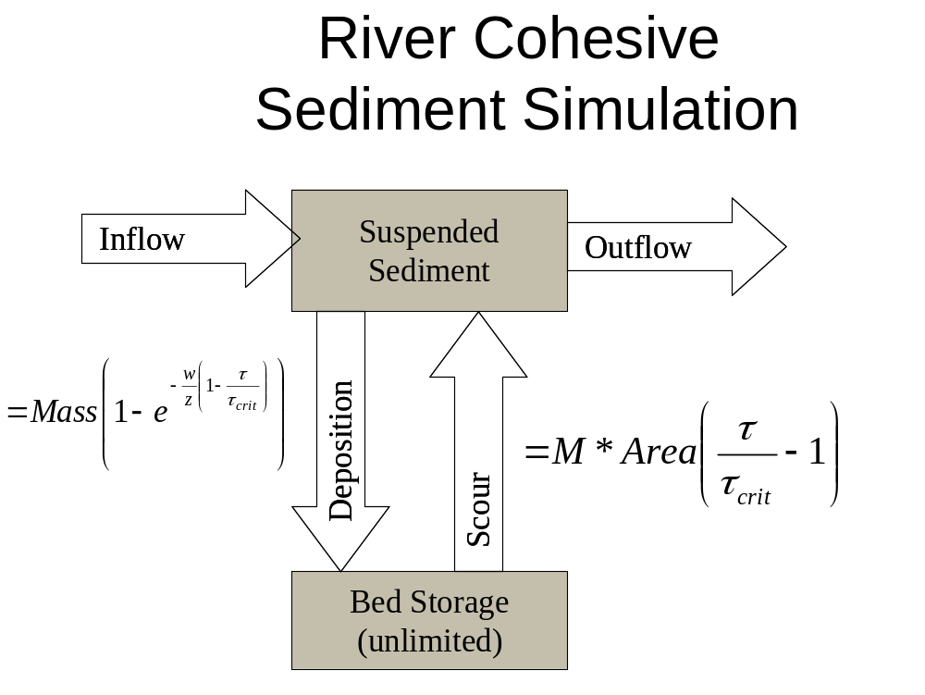

Figure 9.5.1. Schematic of the silt and clay cohesive sediment simulation.

Sand is simulated differently from cohesive sediments. The amount of sand transported in a reach is determined by the transport capacity of the flow which is a power function of the average velocity in the reach. Deposition of sand will occur if the concentration of sand in the reach exceeds its transport capacity of the flow and sand will be scoured from the bed if the concentration of sand is below the transport capacity (Figure 9.5.2). Table 9.5.1 summarizes the HSPF parameters used in the sediment calibration in the reaches.

Table 9.5.1. Key Parameters for Sediment Transport Calibration
Parameter | Description
TAUCD | Critical bed shear stress for deposition
TAUCS | Critical bed shear stress for scour
W | Fall velocity in still water
M | Erodibility coefficient
KSAND | Coefficient of sand load power function
EXPSND | Exponent of sand load power function

Calibration of Sediment Concentrations and Loads in River Reaches
There are 164 sediment calibration points with varying numbers of observations. All ungaged river segments upstream of a calibration point have identical parameters of depositional and scour shear stress for silt and clay as shown in Figure 9.5.3.

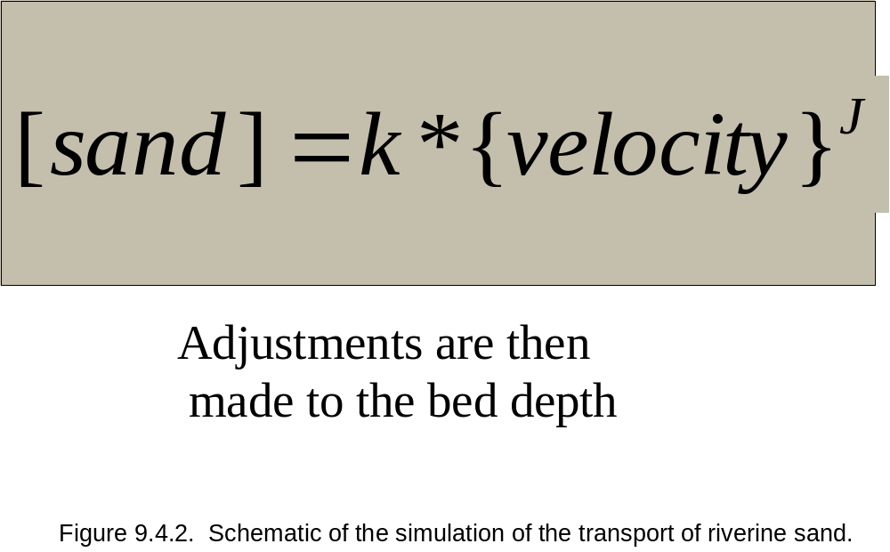

Remington
Robinson
Rappahannock

Figure 9.5.3. All rivers segments upstream of a calibration point have identical parameters as shown in this figure of three sediment monitoring stations with three separate calibrations.

Sediment calibration can be confounded due to inaccuracies in the flow simulation. If peak flow is missed by one day, then the sediment concentration may not match observed values at that point, but should match it at the point when the peak was simulated. In order to take this into account, the simulation was checked 24 hours before and after an observation point and the simulation value for that observation was set to the point closest to the observed value to better represent the in the daily calibration occasions when the sediment peak was correctly simulated, but the timing was missed by >24 hours.

The calibration rules were applied by an automated calibration system called AIM for Automated Iterative Method. The AIM is described in Section 13 for calibrating both EoF and riverine transported sediment. Many larger stations have more data available and are often easier to calibrate than smaller stations. Further, larger stations may be more important overall since they are a composite of many smaller upstream reaches which are more affected by local phenomena.

A key goal of the calibration was to match observed and simulated concentrations and loads at high flows. High flows are considered to be the highest 30% percentile of the flow. High flows encompass storm flows which transport sediment eroded from the land. Below the 30% percentile of flow, most of the observed total suspended solids are organic solids. These were calibrated to match the observed data, but that was not the primary focus of the calibration. Figure 9.5.4 and Table 9.5.y show locations and names of all the sediment calibration stations used in the Phase 5 calibration [NEED TO MAKE FIGURE 9.5.4 AND TABLE 9.5.2].

9.6 Assessment of the Sediment Calibration
Discuss the weight of evidence approach here.

9.6.1 Quality of the Land Use Calibration to Literature Targets
Need to add this section.

9.6.2 Quality of the Riverine Calibration to Observed Data At Monitoring Stations
Many different measures were used to assess the agreement between observed and simulated sediment concentrations and loads. These include
- Summary statistics such as minimum, mean, maximum, and median values;
- Time series plots;
- Scatter plots of concentration or log concentration;
- Cumulative distribution of paired observed and simulated concentrations or log concentrations; and
- Statistical measures of correlation such as model efficiency or coefficients of determination.

[NOTE: Subcommittee members suggested a plot showing the quality of the calibration, such as model efficiency, with respect to watershed size and we need to add this.]

Rating curves, representing the relation between flow and sediment concentration, were also compared. A special set of plots and statistical measures were developed to take into account the following three problems in comparing sediment simulations to observed values:
  - Sediment concentrations vary widely over a storm, but most available sediment observations consist of grab samples taken at a moment in time.
  - Simulated storms can lead or lag the real events, so simulated concentrations or loads can be in essential agreement with their observed counterparts but lead or lag them in time; and, as previously noted,
  - Over a wide range of low flows, suspended sediment concentrations are low, contribute little to sediment loads, and made up mostly of organic solids.

To take into account these problems, “windowed” plots and statistical measures were adopted. In a windowed plot, observed data are compared to a one-day window of simulated values, before and after the observation. If the observation falls with the range of simulated values, the simulated value is set equal to the observed value. If the range of simulated values is above or below the observed value, then the simulated value is set equal to the minimum or maximum simulated value, respectively. This procedure was used for both concentrations and loads. Figure 9.6.2.1 shows an example of windowed concentration plots for the Potomac River at Chain Bridge; Figure 9.6.2.2 shows the windowed load plots for Chain Bridge.

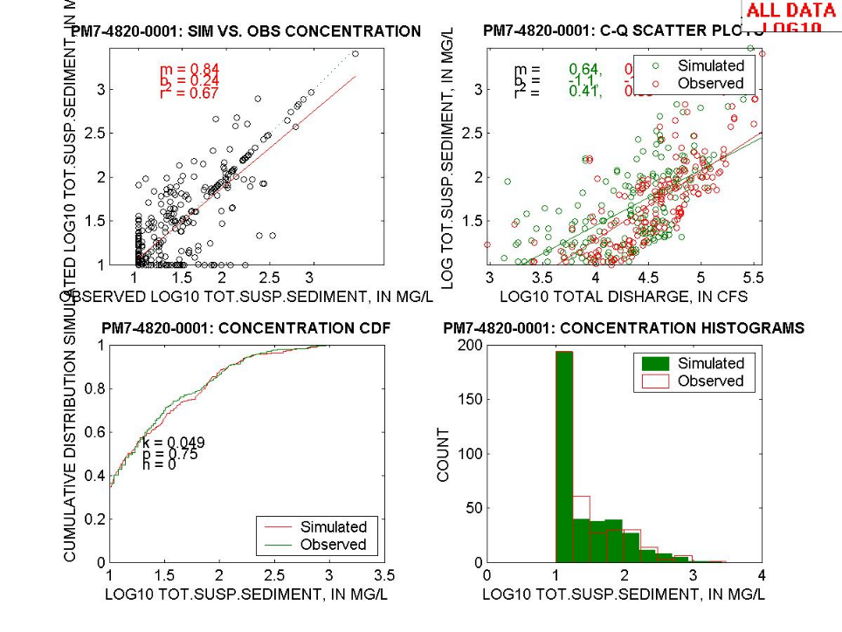

Figure 9.6.2.1. Windowed Concentration Plots, Potomac River at Chain Bridge.
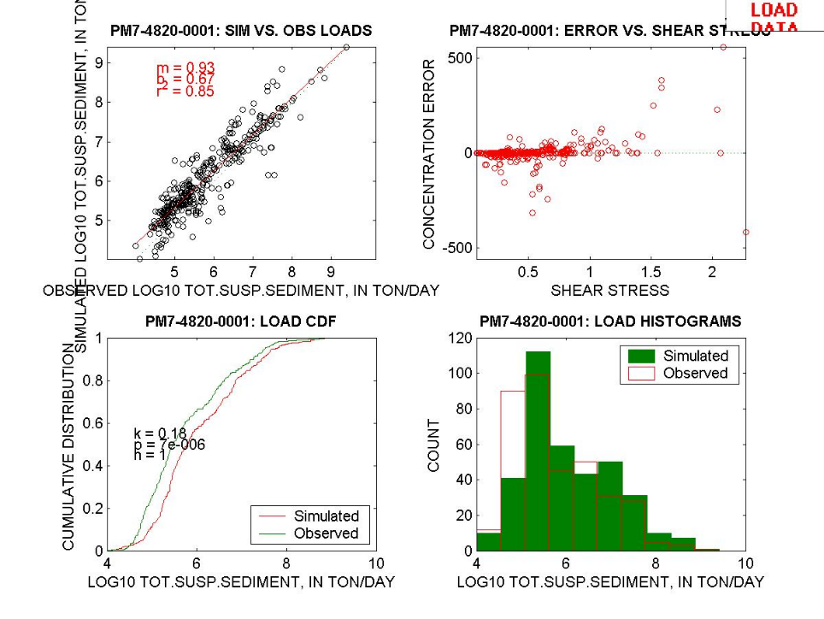

Figure 9.6.2.2. Windowed Load Plots, Potomac River at Chain Bridge.

Table xx [NEED TO MAKE THIS TABLE] gives the coefficient of determination between observed and simulated (1) sediment concentrations, (2) log sediment concentrations, (3) windowed log sediment concentrations, and (4) windowed loads for the sediment calibration stations. It is difficult to summarize the overall quality of the sediment calibration. Conventional measures comparing simulated and observed values tend to overestimate the importance of low flow concentrations. Windowed comparisons may be too generous in finding agreement between simulated and observed values. Unlike the hydrology calibration, the sediment calibration is more a matter of visual inspection and best professional judgment.

Another assessment of the quality of the sediment calibration is comparison with the monthly load estimates from the USGS’s River Input Monitoring (RIM) program, which evaluates nutrient and sediment loads entering Chesapeake Bay and its tidal tributaries at the fall line. RIM loads are calculated using the USGS’s ESTIMATOR software, which calculates monthly and annual constituent loads based on a statistical analysis of the relation between constituent concentrations and flow, time, and seasonality. Langland et al. (2001) has more details on the RIM program and ESTIMATOR. This comparison is also relevant to the integration of the SPARROW Model with Phase 5 as the SPARROW Model is based on ESTIMATOR.

Figures 9.6.2.3, 9.6.2.4, and 9.6.2.5 compare the log-transformed monthly sediment loads from ESTIMATOR with Phase 5 Watershed Model loads for the RIM stations at Chain Bridge on the Potomac River, the Patuxent River at Bowie, and the Choptank River near Greensboro. There is good agreement between ESTIMATOR and the Phase 5 Model, both in the overall magnitude of the loads and their variability.

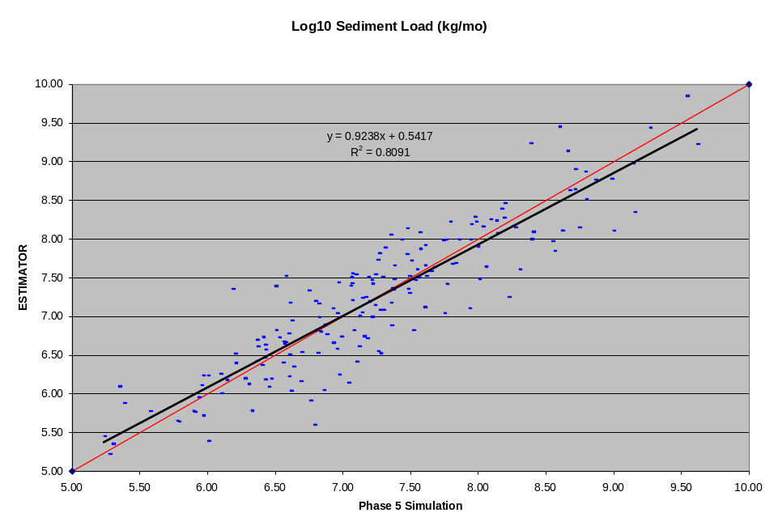

Figure 9.6.2.3. Monthly Sediment Loads, Potomac River at Chain Bridge.

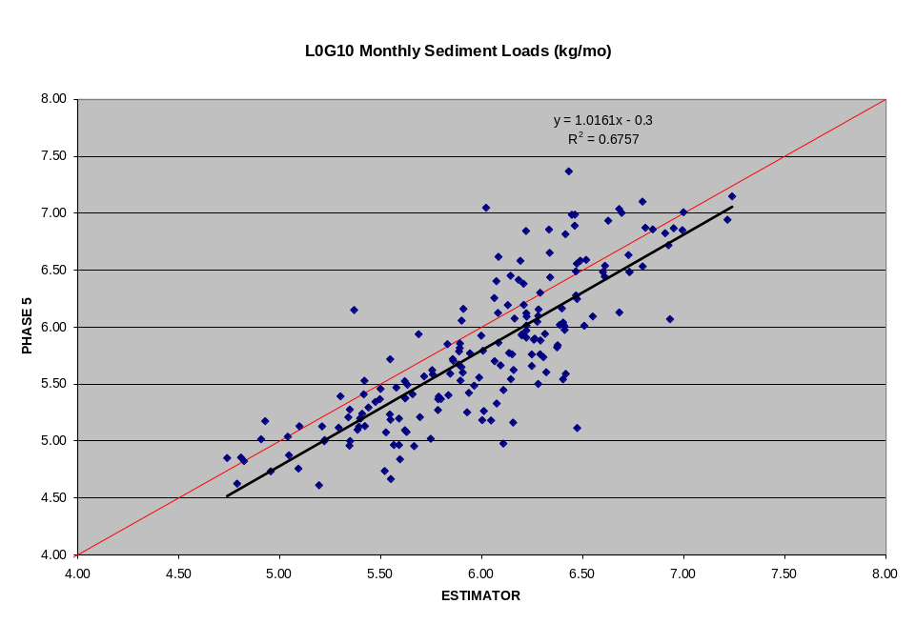

Figure 9.6.2.4 Monthly Sediment Loads, Patuxent River at Bowie.

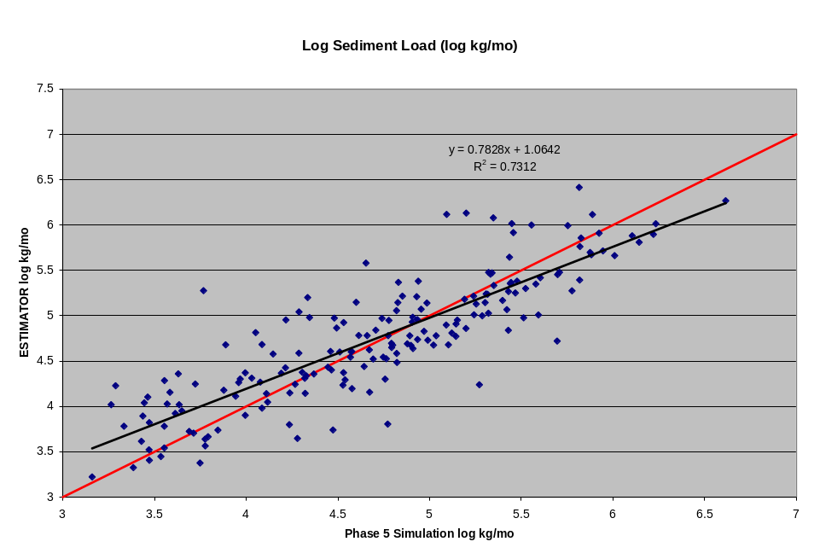

Figure 9.6.2.5. Monthly Sediment Loads, Choptank River at Greensboro.

9.6.3 Calibration of Sand, Silt, and Clay Fractions
Phase 5 simulates sand, silt, and clay separately in the river reaches. We add the three sediment components, plus freshwater phytoplankton, to get simulated total suspended solids (TSS) consistent with observed total suspended solids at monitoring stations.

The River Input Monitoring (RIM) stations have some data on observed splits of sand and fines (silt and clay). Using all available observations taken at the Chesapeake Bay RIM stations, which correspond to the last water quality monitoring station before discharge to tidal waters (also called the fall line monitoring stations), we find the TSS observed loads were mostly fines (Table 9.6.3). The major basins of the Susquehanna, Potomac, and James have median percent fines of 97%, 91%, and 85 % respectively (Figures 9.6.2.6, 9.6.2.7, and 9.6.2.8). Usually rivers with significant impoundments, like the Susquehanna have a greater percentage of fines and the sand fraction is more typically 5%. Surprisingly, no correlation was seen between flow and percent fines.

To reflect the observations of the proportions of sand and fines observed TSS, the annual average target of percent sand was set at 15% for all river reaches except for those reaches which have impoundments. In the case of impoundments, as in the Susquehanna observations with the impoundments of Conowingo, Safe Harbor, and New Haven just above the monitoring station, an annual average target of 5% sand was set which approximates the observed median and mean of 3% and 4.7% respectively.

Only three samples are available for the silt/clay splits and they indicate that the percent clay was 52% and 46% on two occasions in the Patuxent, and was 79% on one occasion in the Potomac.

Table 9.6.3. Percent fines (silt and clay) in Chesapeake Bay Rivers.

 | % fines | % fines | % fines | % fines
BASIN | Median | Mean | Max | Min
Susquehanna | 97 | 95.3 | 100 | 71
Potomac | 91 | 87.6 | 100 | 47
Patuxent | 92 | 89.9 | 100 | 49
Rappahannock | 85 | 80.6 | 100 | 6
Mattaponi | 81 | 76.9 | 100 | 5
Pamunkey | 87 | 84.5 | 100 | 9
James | 85 | 81.1 | 100 | 19
Appomattox | 90 | 85.1 | 100 | 47
Choptank | 90 | 86.3 | 100 | 50

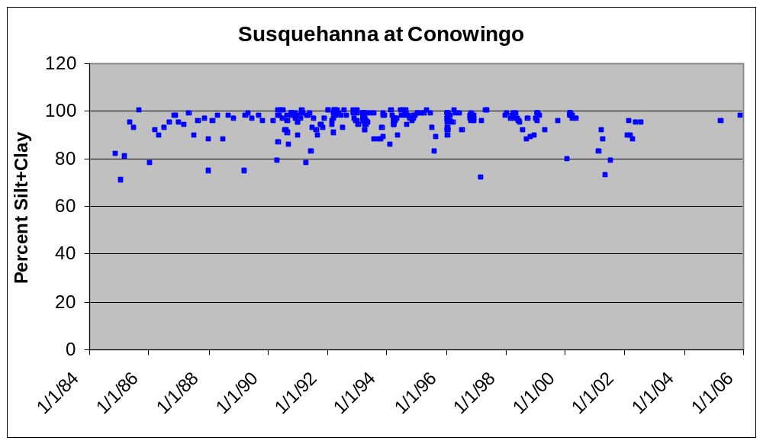

Figure 9.6.2.6. Percent fines (silt + clay) of all observed data from 1985 to 2005 at the Susquehanna Conowingo monitoring station.

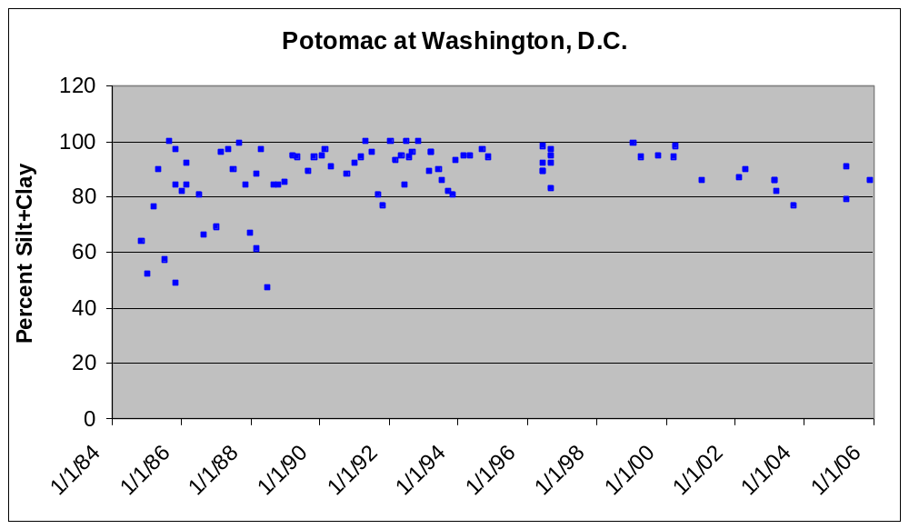

Figure 9.6.2.7. Percent fines (silt + clay) of all observed data from 1985 to 2005 at the Washington, D.C. Potomac monitoring station.

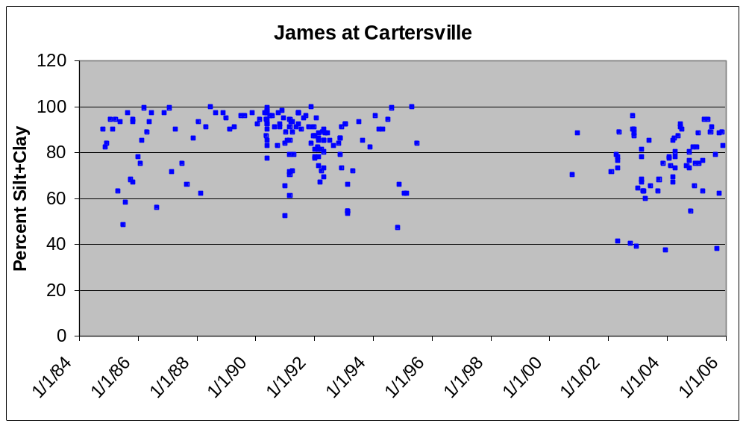

Figure 9.6.2.8. Percent fines (silt + clay) of all observed data from 1985 to 2005 at the James Cartersville monitoring station.

9.7 Assessment of Sediment Loads In the Watershed
Sediment is conservative and its fate after mobilization is to be either stored somewhere in the watershed or transported to tidal waters. A study by Trimble (1999) in Coon Creek, a tributary to the Mississippi River, found that much of the sediment eroded from the land is stored somewhere in the watershed, either on adjacent lands, the reverse slopes of fields, lower order streams, or in river valleys and flood plains. Trimble and others (Walling, 1983; Trimble, 1999; Trimble and Crosson, 2000; Walter et al., 2007; Walter and Merritts, 2008) have described these legacy sediments stored in the watershed as having times of transport to tidal waters like the Chesapeake on the order of decades to centuries. This sediment lag-time also arises from mechanisms specific to the Chesapeake watershed, since the colonial settlement of the East Coast and development of water power sources from relatively low head dams right up to the close of the 19th century (Walter and Merritts, 2008).

To account for the difference between sediment from the land sources and BMPs used to control this sediment, and the sediment loads from legacy sediment and the very different management practices needed to control this source, methods were developed in Phase 5 to differentiate between the two. The erosion loads from the land are defined in Phase 5 to be the erosion loads from the land, developed by calibration to the targets derived either from the National Resource Inventory (NRI) erosion data set, or by literature values, and then decremented by a transport factor relating an edge-of-field erosion load to from a land use to and edge-of-stream (EoS) load. This is considered to be the load from land controlled by BMPs.

Another portion of the sediment load delivered to the Bay is the sediment load mobilized in river reaches, and is defined as the difference between the EoS erosion load and the sediment load scoured and mobilized in the simulation during high flows. This scour term is best conceptualized as high flow and scour from any stream reach, stream bank or flood plain within a model segment. The sediment loads from scour may, in total or in part, be from legacy sediment loads, but greater discernment among the sediment load sources within the Phase 5 simulation system is impractical.

In Phase 5, the legacy sediment is described as an unknown portion of the sediment load delivered to the Bay that was attributed to scour in the watershed from a source other than that of the land uses. This is done with the scour term that is related to the velocity of the river flow (TAUCS). Above some threshold of flow, scour occurs at a specific rate. At lesser flows another critical point is reached and at flows less than this point, sediment settling and deposition occurs. The rate of scour, deposition, and the critical flows where these processes occur are specified in the calibration, and are values that best represent the sediment concentration at the ~130 monitoring stations we have for sediment. This system allows a representation of estimated erosion rates from the land, and estimated sediment loads derived from scour or remobilization of sediment within a model segment. Both the estimated erosion rates from land and the river network are calibrated, one from NRI estimates and one from river monitoring gages. The sediment loads for each of the Phase 5 model segments are represented as both an estimated land erosion load and a river network sediment load.

9.8 Linkage of Sediment loads to the Water Quality and Sediment Transport Model
The Phase 5 Model estimates the general splits between sand, silt, and clay with the fractions changing as the hydrologic condition changes yielding larger size fractions in larger flows. The daily splits of sand, silt, and clay as estimated by the Phase 5 Model were directly input in the Water Quality Sediment Transport Model (WQSTM) though the portions of silts and clays are poorly defined by available observed data.

For sediment loads from the coastal plain regions, loads were determined solely by the sediment edge-of-field loads as adjusted by the edge-of-field to edge-of-stream sediment transport factors. This has the effect of damping the effect of high flows on sediment loads because the river reach simulation amplifies high sediment loads under high flows and low sediment loads under high flows due to the model’s scour and deposition parameterization. This simulation approach on the coastal plain is perhaps consistent with the coastal plain’s low gradients and competency to move sediment in relatively small basins. Other factors that could contribute to lower sediment loads from the Delmarva Peninsula, are the sandy soils of high permeability of the surficial aquifer found there.

The splits of sand and fines in coastal plains is also consistent with the above approach. Without a reach, a percent sand target of 15% in free-running reaches and 5% in impounded reaches is unattainable. In simulated Phase 5 coastal plain regions the sand/fines splits are set by the STASTGO assessment of percent sand in the land segments (Schwarz and Alexander, 1995). The STASGO percent sand is what’s assumed to be eroded at the edge-of-field and the edge-of-stream percent sand is assumed to be an order of magnitude less than this. This varies from land-segment to land-segment, but on average is about 5% sand and 95% fines in the loads delivered to tidal waters from coastal plain regions without a Phase 5 reach.

References
Angle, J. S., G. McClung, M.S. McIntosh, P.M. Thomas, and D.C. Wolf. 1984. Nutrient losses in runoff from conventional and no-till corn watersheds Journal of Environmental Quality 13:3 pp:431-435.

Angle, J.S. 1985. Effect of cropping practices on sediment and nutrient runoff losses from tobacco. Scientific Article No. 7120 and Contribution No. A4135 of the Maryland Agri. Exp. Sta., Dept of Agronomy, Univ. of Maryland College Park, MD Type: Tobacco Science 109.

Arthur, M.A., G.B. Coltharp, and D.L. Brown. 1998. Effects of best management practices on forest streamwater quality in Eastern Kentucky Journal of the American Water Resources Association 34:3 pp:481-495.

Camacho, R. 1990. Agricultural BMP Nutrient Reduction Efficiencies: Chesapeake Bay Watershed Model BMPs Interstate Commission on the Potomac River Basin, ICPRB Report 90-7. Rockville, MD.

Castro, M. S., K.N. Eshleman, R.P. Morgan II, S.W. Seagle, R.H. Gardner, and L.F. Pitelka. 1997. Nitrogen dynamics in forested watersheds of the Chesapeake Bay STAC Report Number: 97-3 Scientific and Technical Advisory Committee, Frostburg, MD, June 1997.

Curry, L. 2006. An analysis of sediment EoF to EoS transport factors in Chesapeake physiographic regions. (personal communication).

Dreher, D., and T. Price. 1995. Application of urban targeting and prioritization methodology to Butterfield Creek, Cook and Will Counties, Illinois. National Conference on Urban Runoff Management—Enhancing Urban Watershed Management at the Local, County, and State Level, EPA/625/R-95/003, pp:119-134.

Frick, E.A., and G.R. Buell.1999. Relation of land use to nutrient and suspended sediment concentrations, loads, and yields in the upper Chattahoochee River basin, Georgia, 1993-98. Ed: Hatcher, Kathryn J. 1999 Georgia Water Resources Conference University of Georgia Athens, GA.

Grace, J. M. 2004. Soil erosion following forest operations in Southern Piedmont of central Alabama Journal of Soil and Water Conservation 59:4, pp160-166.

NEED Guy and Furguson (1962) HERE.

Hewlett, J.D., W. P. Thompson, and N. Brightwell. 1979. Erosion Control On Forest Land In Georgia. Institution: University of Georgia and U.S. Dept. of Ag. Soil Conservation Service pp:24, Athens, Ga.

Keppeler, E., J. Lewis, and T. Lisle. 2003. Effects of Forest Management on Streamflow, Sediment Yield, and Erosion, Caspar Creek Experimental Watersheds. Agricultural Research Service. <www.tucson.ars.ag.gov/icrw/Proceedings/keppeler.pdf>. Accessed September 20, 2007.

Langdale, G. W., R.A. Leonard, and A.W. Thomas. 1985. Conservation practice effects on phosphorus losses from Southern Piedmont watersheds Journal of Soil and Water Conservation January-February pp:157-161.

Langland, M. and T. Cronin. 2004. A Summary Report of Sediment Processes in the Chesapeake Bay and Watershed. Water-Resources Investigations Report 03-4123. United States Geological Survey. New Cumberland, PA.

Langland, M., and T. Cronin. 2003. A Summary Report of Sediment Processes in Chesapeake Bay and Watershed Water-Resources Investigations Report 03-4123, November, 2003, pp:122, USGS, New Cumberland, Pennsylvania.

Letter to Aqua Terra Consultants from U.S. EPA Chesapeake Bay Program Office, November 9, 1990.

Metropolitan Washington Council of Governments (MWCOG). 1987. Controlling Urban Runoff: A Practical Manual for Planning and Designing Urban BMPs. Metropolitan Washington Council of Governments, Washington, D.C.

National Resources Inventory (NRI). 2007. Natural Resources Conservation Services.<http://www.nrcs.usda.gov/TECHNICAL/land/nri03/nri03eros-mrb.html>. Accessed September 20, 2007.

Nusser, S. M., and J. J. Goebel. 1997. "The National Resources Inventory: A Long-Term Multi-Resource Monitoring Programme," Environmental and Ecological Statistics, 4(3):181- 204.

Palace, M,W., J.E. Hannawald, L.C. Linker, G.W. Shenk, J.M. Storrick, and M. Clipper. 1998. Chesapeake Bay Watershed Model Application and Calculation of Nutrient and Sediment Loadings - Appendix H : Tracking Best Management Practice Nutrient Reductions in the Chesapeake Bay Program. Report of the Chesapeake Bay Program Modeling Subcommittee, August 1998, pp:77, U.S. EPA Chesapeake Bay Program Office Annapolis, MD.
< http://www.chesapeakebay.net/pubs/777.pdf>. Accessed September 20, 2007.

Perry, D.A. 1998. “The Scientific Basis of Forestry.” Annual Review of Ecological Systems, Volume 29. 1998. (pp435-466).

Revised Universal Soil Loss Equation 2 (RUSLE2). 2007. Natural Resources Conservation Services. http://www.rusle2.org/. Accessed September 20, 2007.

Riekerk, H., D.G. Neary, and W.T. Swank. 1988. The magnitude of upland silviculture nonpoint source pollution in the South. Ed. Hook, Donald D.; Lea, Russ Conference on the Forested Wetlands of the Southern United States, Asheville, NC U.S. Department of Agriculture, Forest Service, Southeastern Forest Experiment Station pp: 8-18.

Schwarz, G.E., and R.B. Alexander. 1995. Soils data for the Conterminous United States Derived from the NRCS State Soil Geographic (STATSGO) Data Base. [Original title: State Soil Geographic (STATSGO) Data Base for the Conterminous United States.] Edition: 1.1 Open-File Report 95-449 Reston, VA U.S. Geological Survey <http://water.usgs.gov/lookup/getspatial?ussoils>. Accessed September 20, 2007.

Shaver, E., R. Horner, J. Skupien, C. May, and G. Ridley. 2007, Fundamentals of Urban Runoff Management: Technical and Institutional Issues: North American Lake Management Society. Madison, WI.

Soil Conservation Service. 1988. Effects of conservation practices on water quantity and quality Editor: Soil Conservation Service, Soil Conservation Water Quality Workshop - Integrating Water Quality and Quantity into Conservation Planning, October 1, 1988, Department of Agriculture, Washington D.C.

Staver, K.W., R.B. Brinsfield, and W.L. Magette, 1988. Tillage effects on phosphorus transport from Atlantic coastal plain watersheds 1988 American Society of Agricultural Engineers Conference, Chicago, Il. Paper No. 88-2651.

Schueler, T. 2007. Managing Watersheds for Drinking Water. Center for Watershed Protection. Ellicott City, MD.

Trimble, S.W. 1997. Contribution of stream channel erosion to sediment yield from an urbanizing watershed: Science, v. 278, no. November 21, 1997, p. 1442-1444.

Trimble, S.W. 1999. Decreased rates of alluvial sediment storage in the Coon Creek Basin, Wisconsin, 1975-93: Science, v. 285, no. August 20, 1999, p. 1244-1246.

Trimble, S.W., and P Crisson. 2000. U.S. Soil Erosion Rates - Myth and Reality, Science Magazine, p. 248-250.

Trickett R. 2006. Personal communication between Rick Trickett (Water Management Administration) and Lee Curry (Maryland Department of Environment) as described in email from Lee Curry 3-24-06.

USDA-NRCS. 1983. Sediment sources, yields, and delivery ratios. Chapter 6 in National Engineering Handbook, Section 3, Sedimentation. U.S. Department Agriculture, Natural Resources Conservation Service formerly Soil Conservation Service (SCS), 6.2-6.19. U.S. Government Printing Office. Washington, D.C.

US EPA (U.S. Environmental Protection Agency). 2005. National Management Measures to Control Nonpoint Source Pollution from Urban Areas (November 2005, EPA-841-B-05-004). Washington, D.C. <http://www.epa.gov/nps/urbanmm/>. Accessed September 20, 2007.

US EPA (U.S. Environmental Protection Agency). 2006. Sediment Parameter and Calibration Guidance for HSPF Basins Technical Note 8, Office of Water, January 2006. pp43.

Van Sickle, J. and R.L. Beschta. 1983. “Supply-Based Models of Suspended Sediment Transport in Streams.” Water Resources Research, 19(3): 768-778

Walling, D.E. 1983. The sediment delivery problem: Journal of Hydrology, v. 65, p. 209-237.

Walter, R.C., and J.D. Merritts. 2008. Natural streams and the legacy of water-powered mills: Science, v. 319, no. 18, 299-304.

Walter, R.C., J.D. Merritts, and M. Rahnis. 2007. Estimating Volume, Nutrient Content, and Rates of Stream Ban Erosion of Legacy Sediment in the Piedmont and Valley and Ridge Physiographic Provinces, Southeastern and Central Pennsylvania: Pennsylvania Department of Environmental Protection Report.

Wang, P., L.C. Linker, and K.N. Eshleman. 2003. Dynamic parameterization to simulate DIN export due to gypsy moth defoliation. in: P.M.A. Sloot et al. (Eds.) Springer-Verlag, Lecture Note in Computer Science, v.2659: 30-38

Wilson, C., P. Wallbrink, and A. Murray. 1999. Minimum Impact Logging Systems in Forest Erosion. Part A: Impact of logging and Natural Fires on Runoff and Soil Loss in Erodible Granite Terrain, Northeast Tasmania. Technical Report 19/99, June 1999, CSIRO Land and Water, Canberra.

Cite as:
USEPA (U.S. Environmental Protection Agency), 2009. Chesapeake Bay Phase 5 Community Watershed Model. In preparation. EPA XXX-X-XX-008 U.S. Environmental Protection Agency, Chesapeake Bay Program Office, Annapolis MD. January 2009.

Revised August 20, 2008

2 ² Revised Universal Soil Loss Equation 2 (RUSLE2). http://www.rusle2.org/ Natural Resources Conservation Services. http://www.nrcs.usda.gov/

